Screenshots Portfolio Milestone Module 4
Landing Page
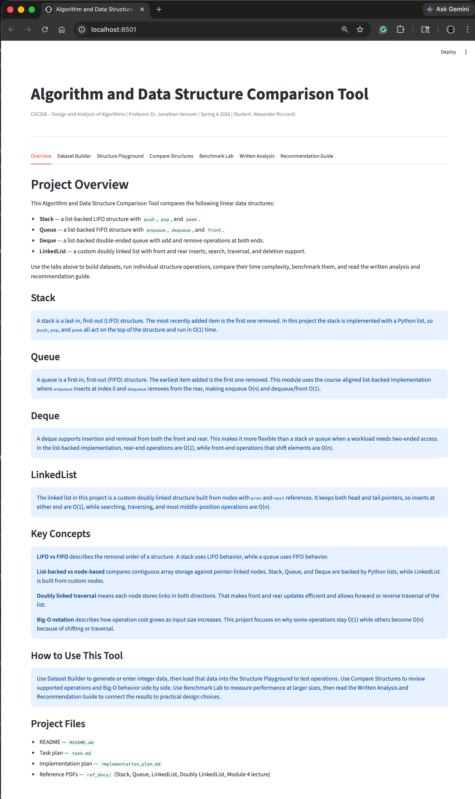
Dataset Builder Feature
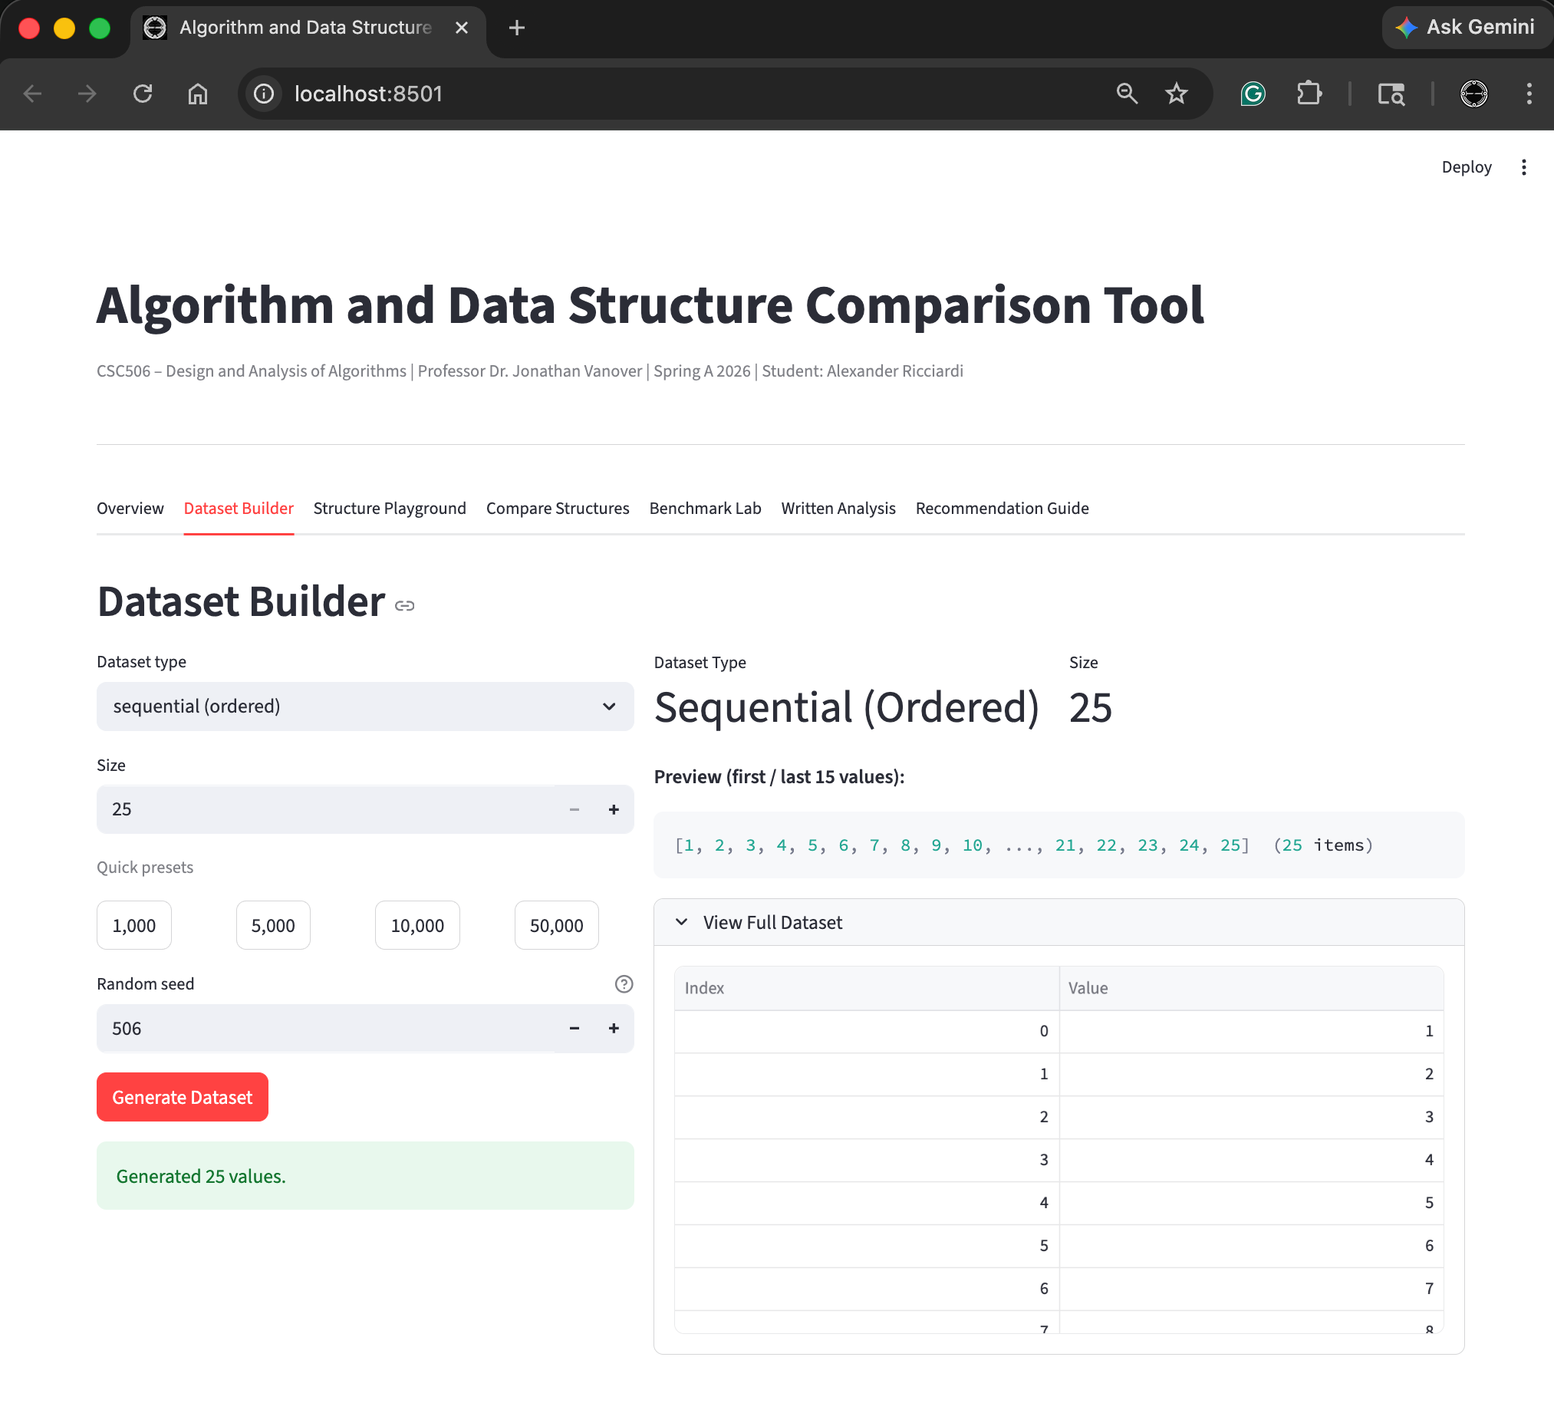

Structure Playground Feature – Stack. Push and Pop
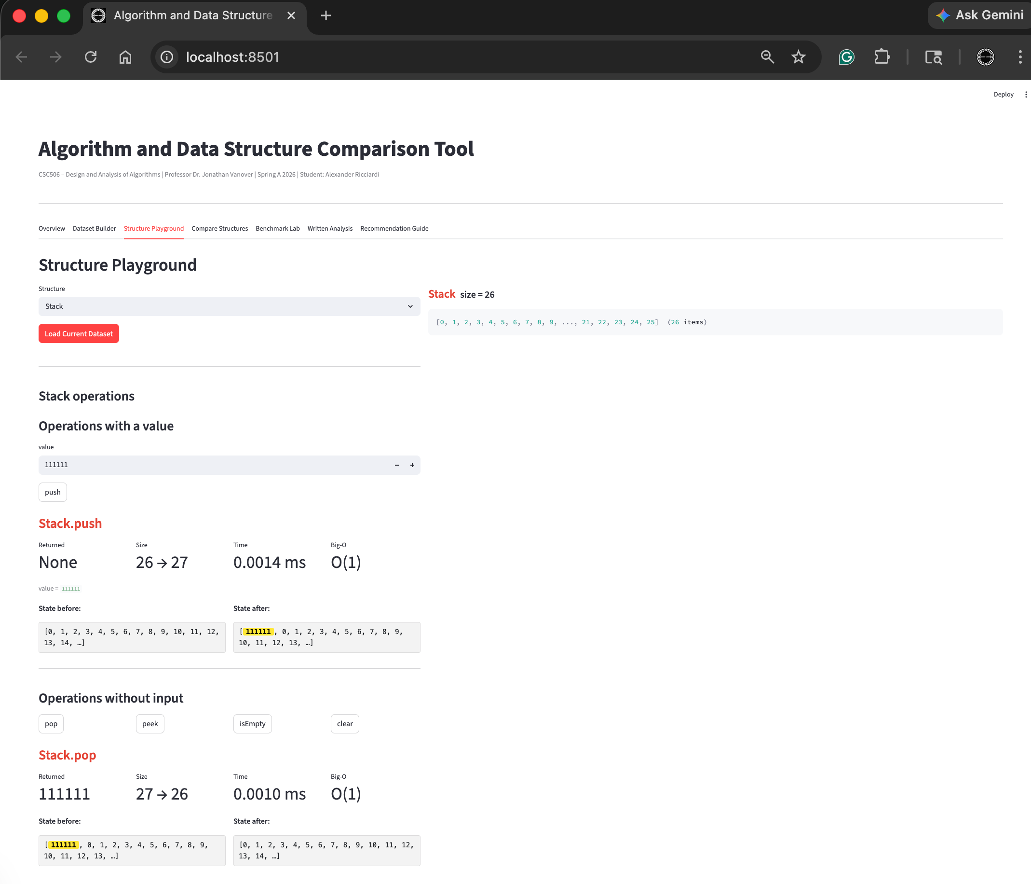

Structure Playground Feature – Stack Peek and IsEmpty
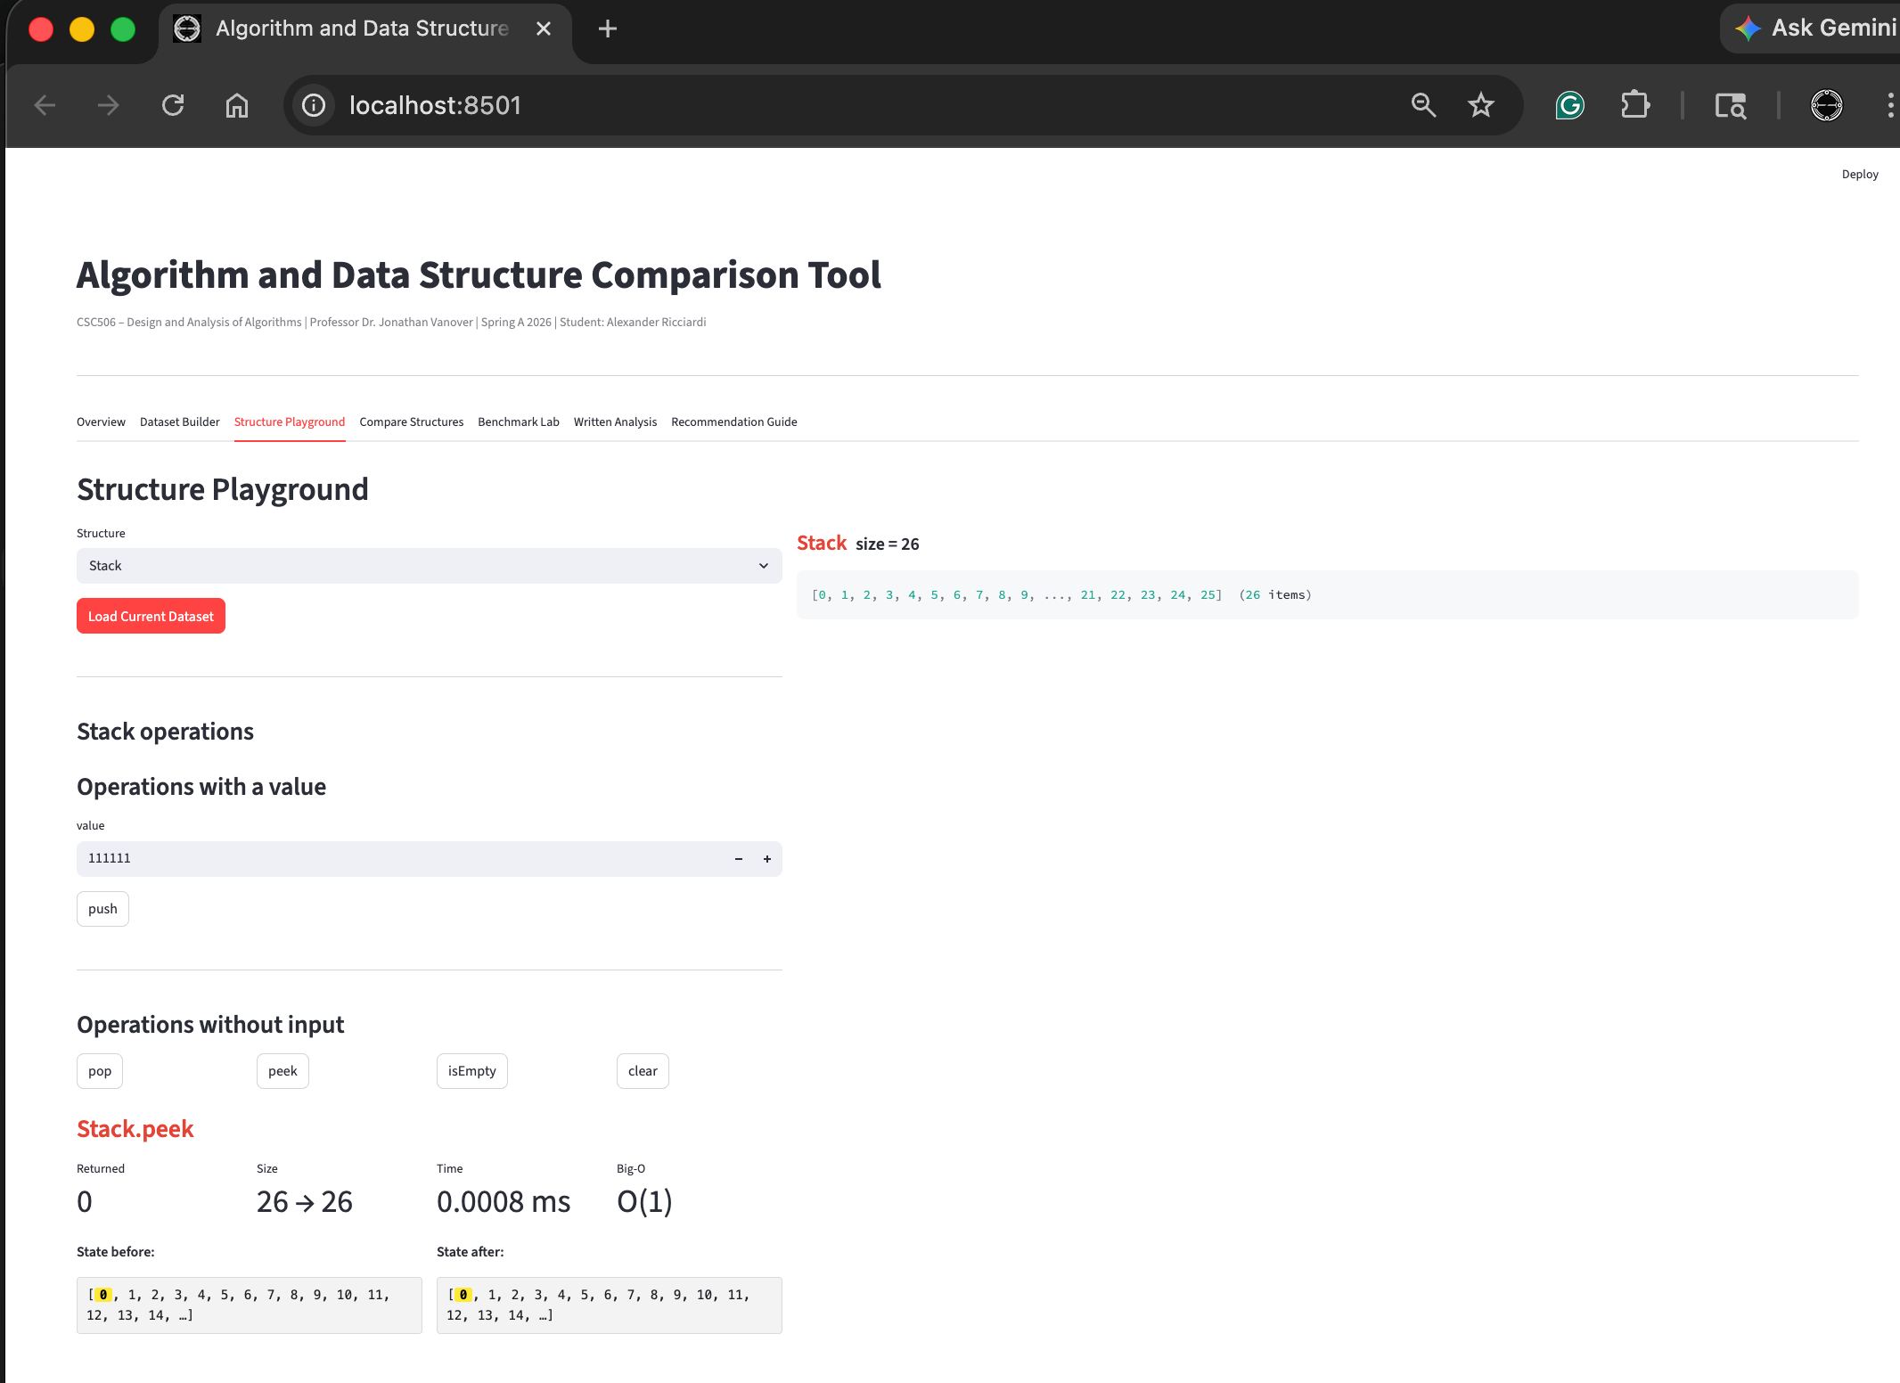
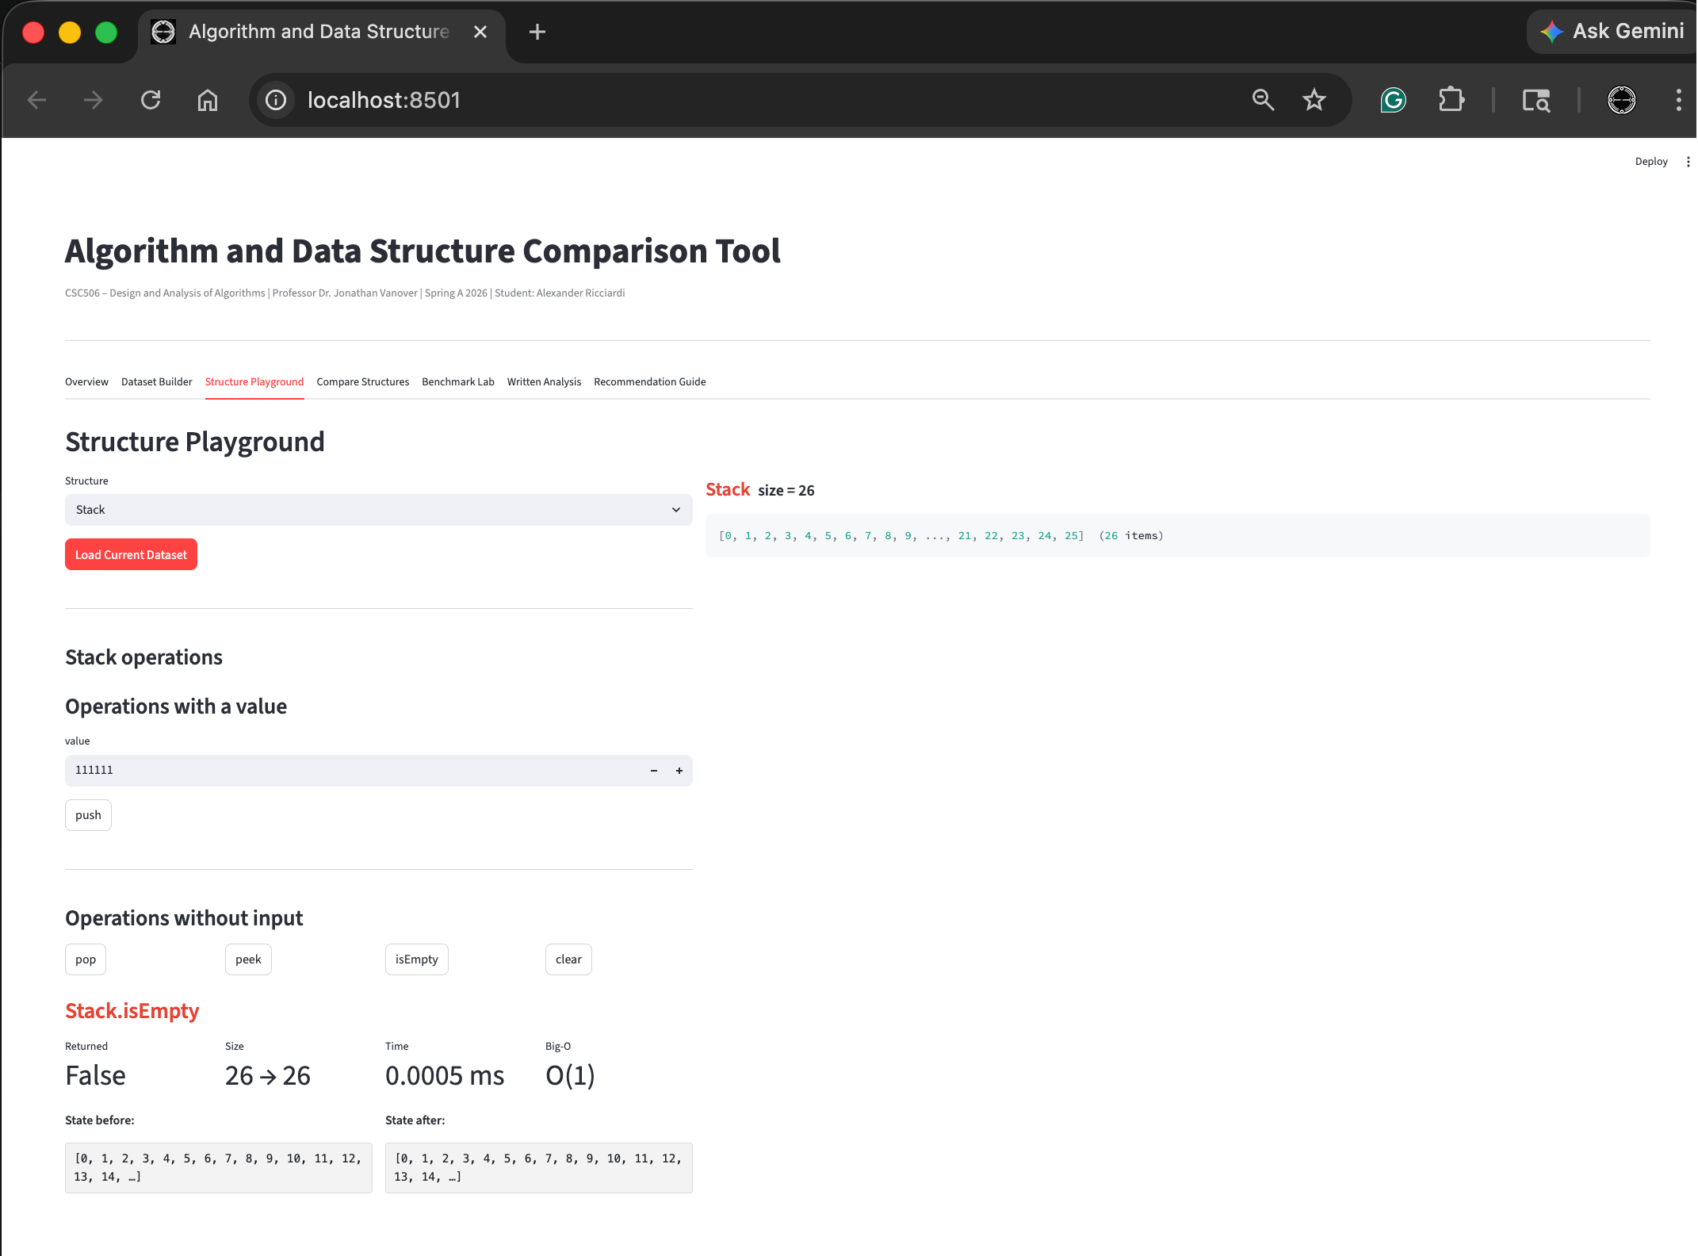
Structure Playground Feature – Stack Clear
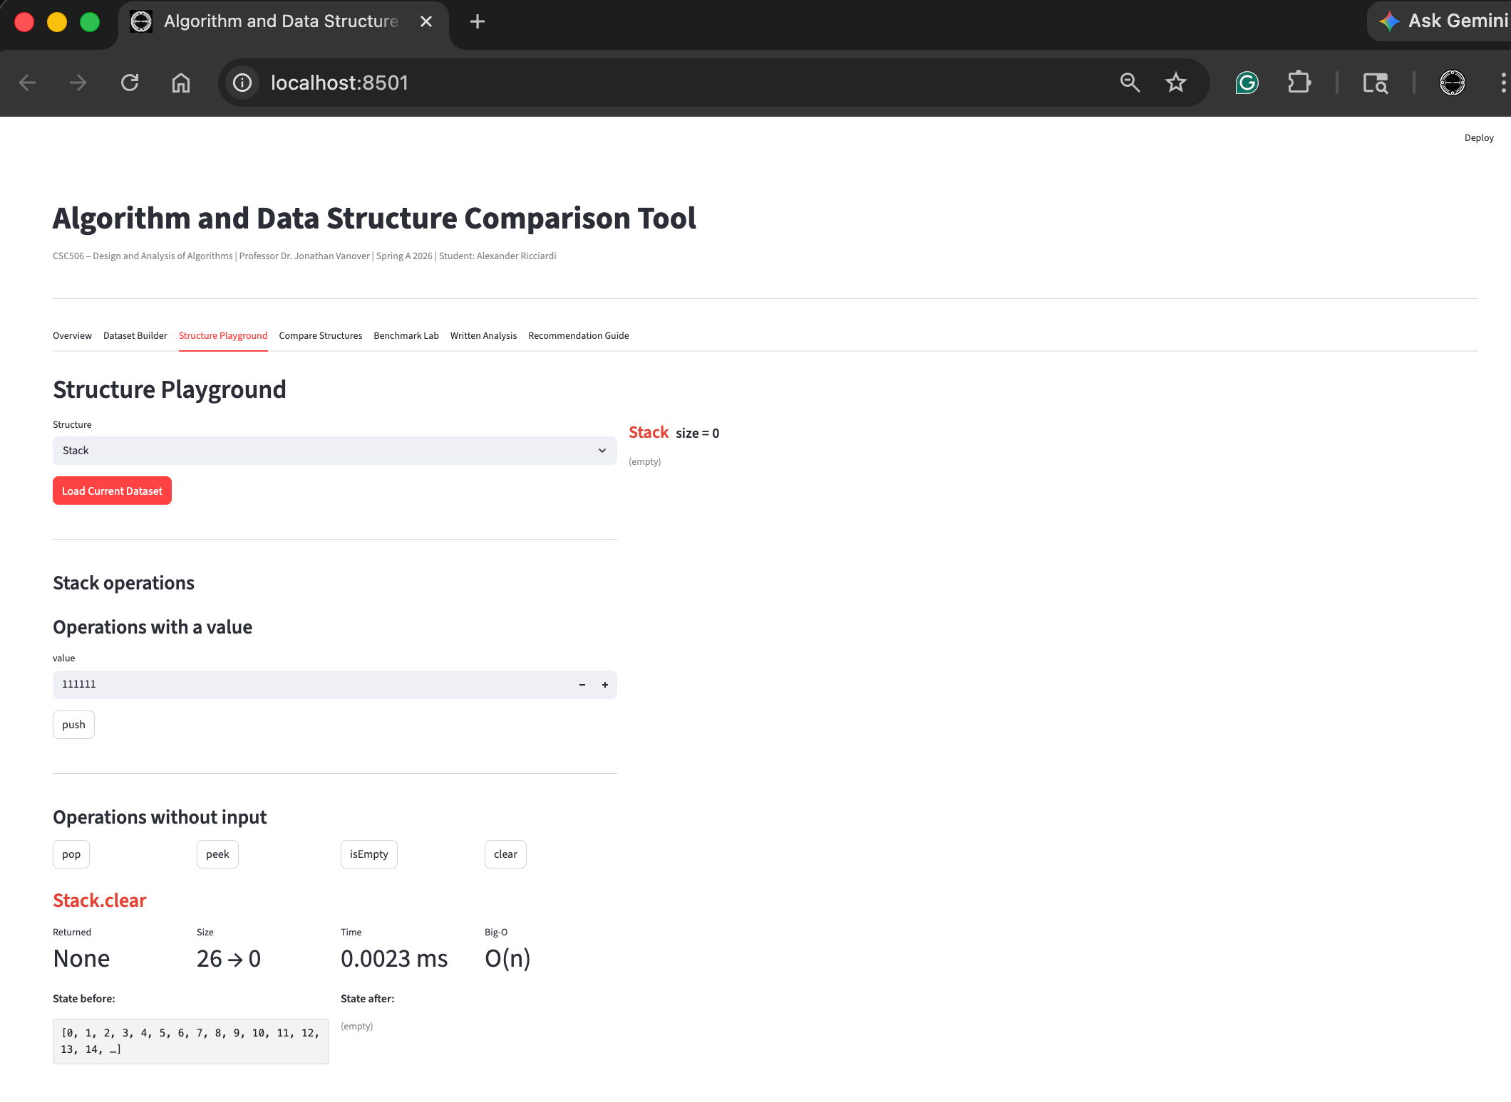

Structure Playground Feature – Queue Enqueue and Dequeue
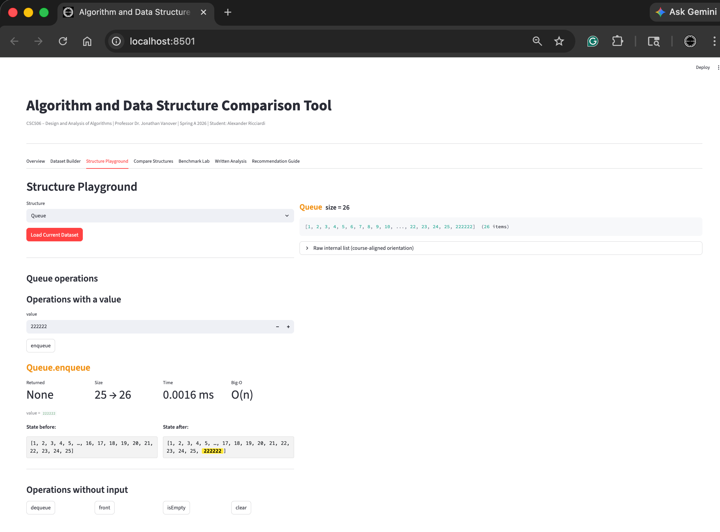
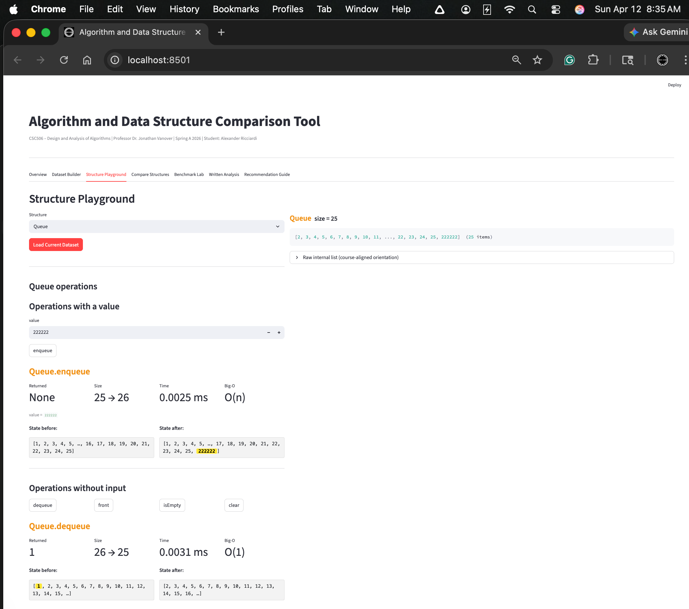
Structure Playground Feature – Queue Front
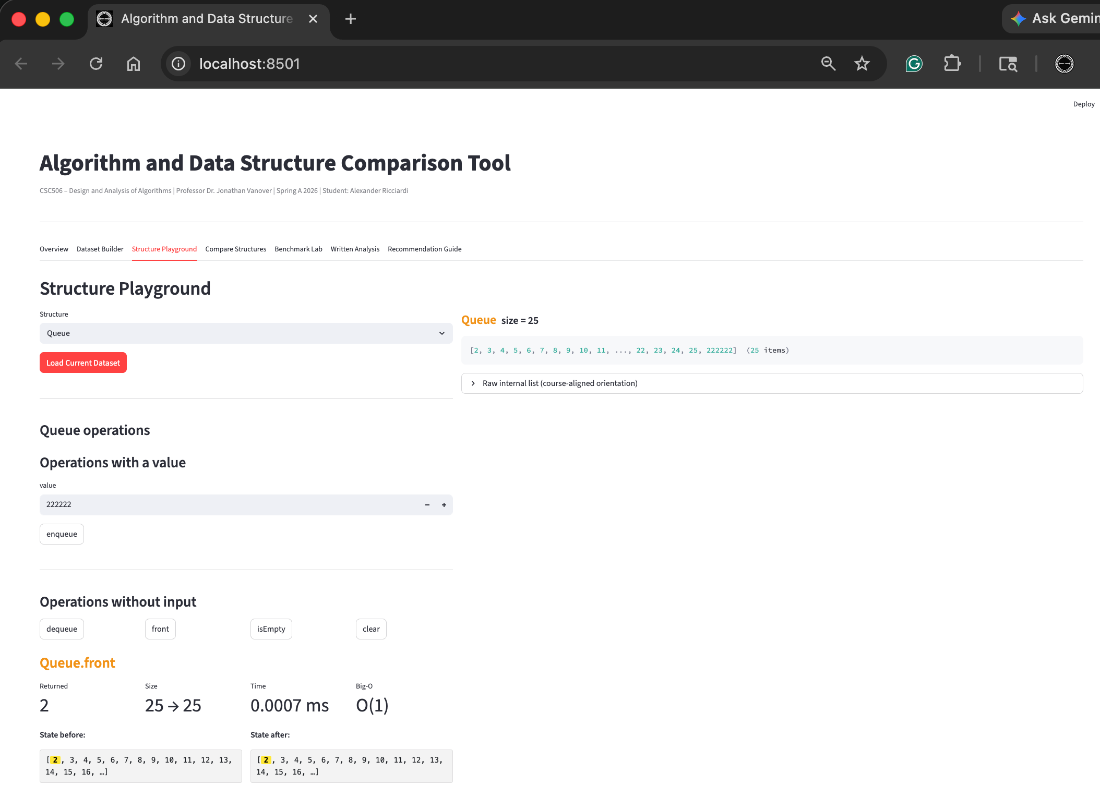
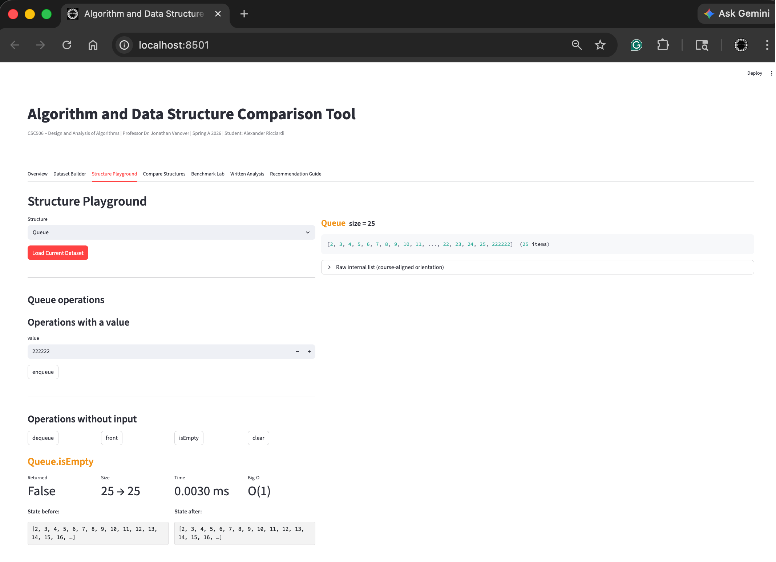
Structure Playground Feature – Queue Clear
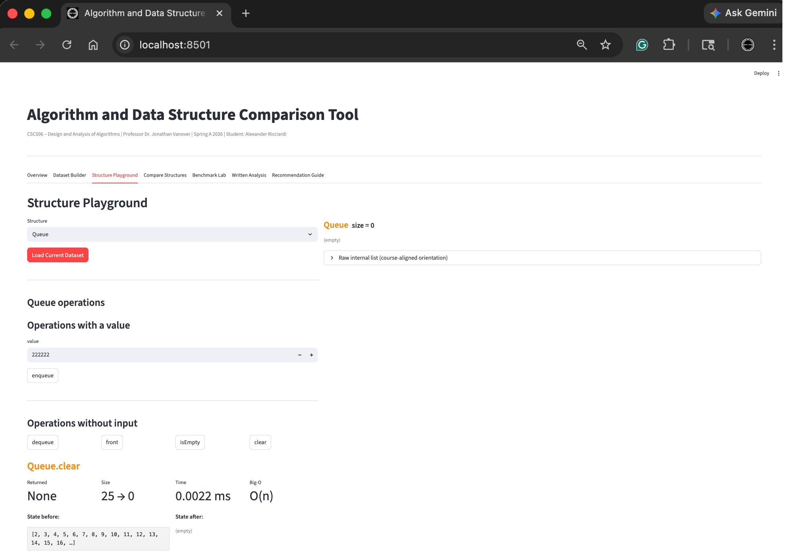

Structure Playground Feature – Dequeue AddFront and RemoveFront
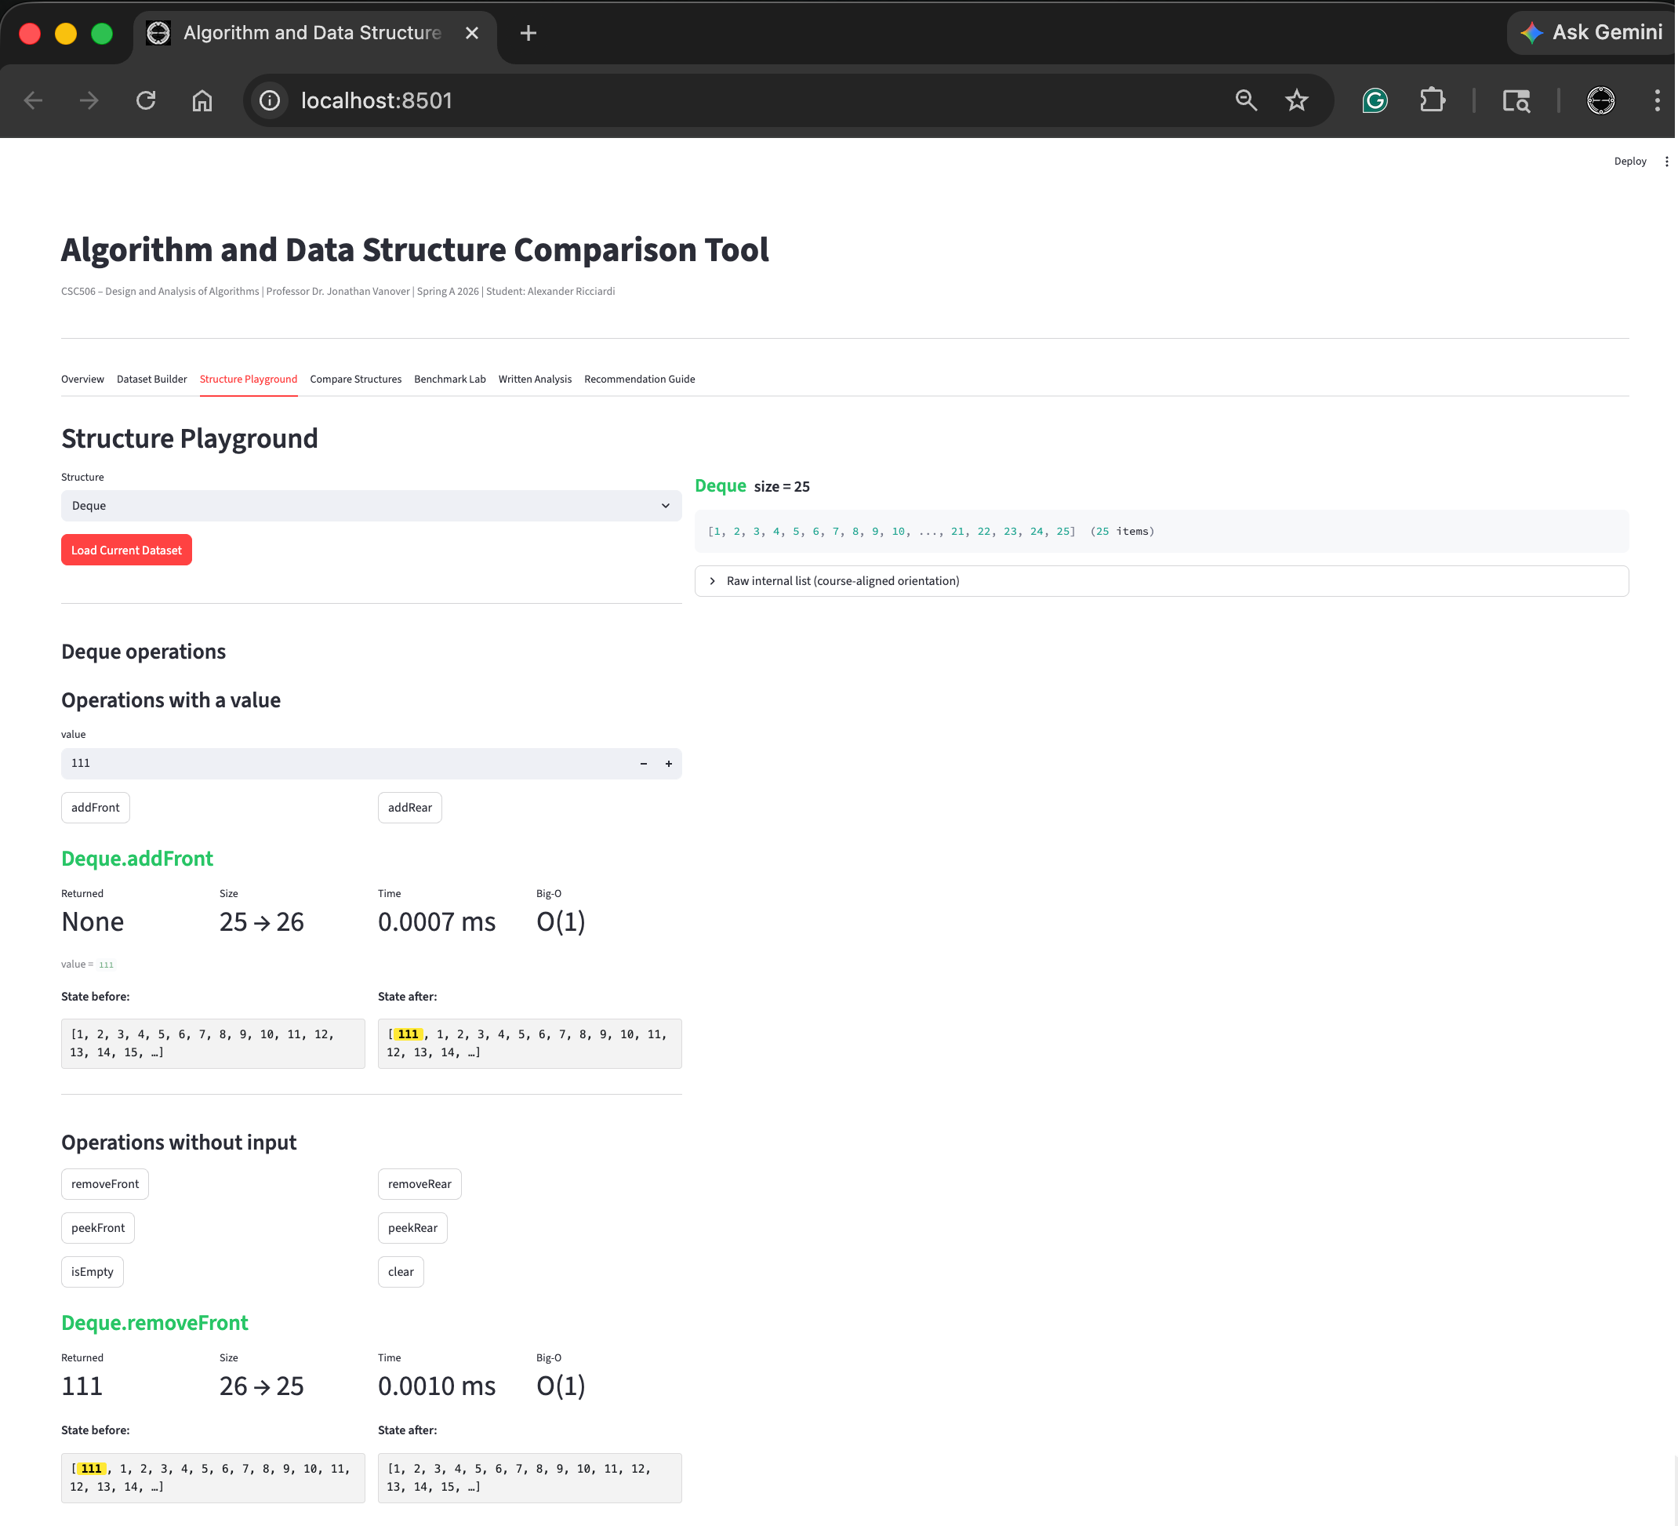

Structure Playground Feature – Dequeue AddRear and RemoveRear
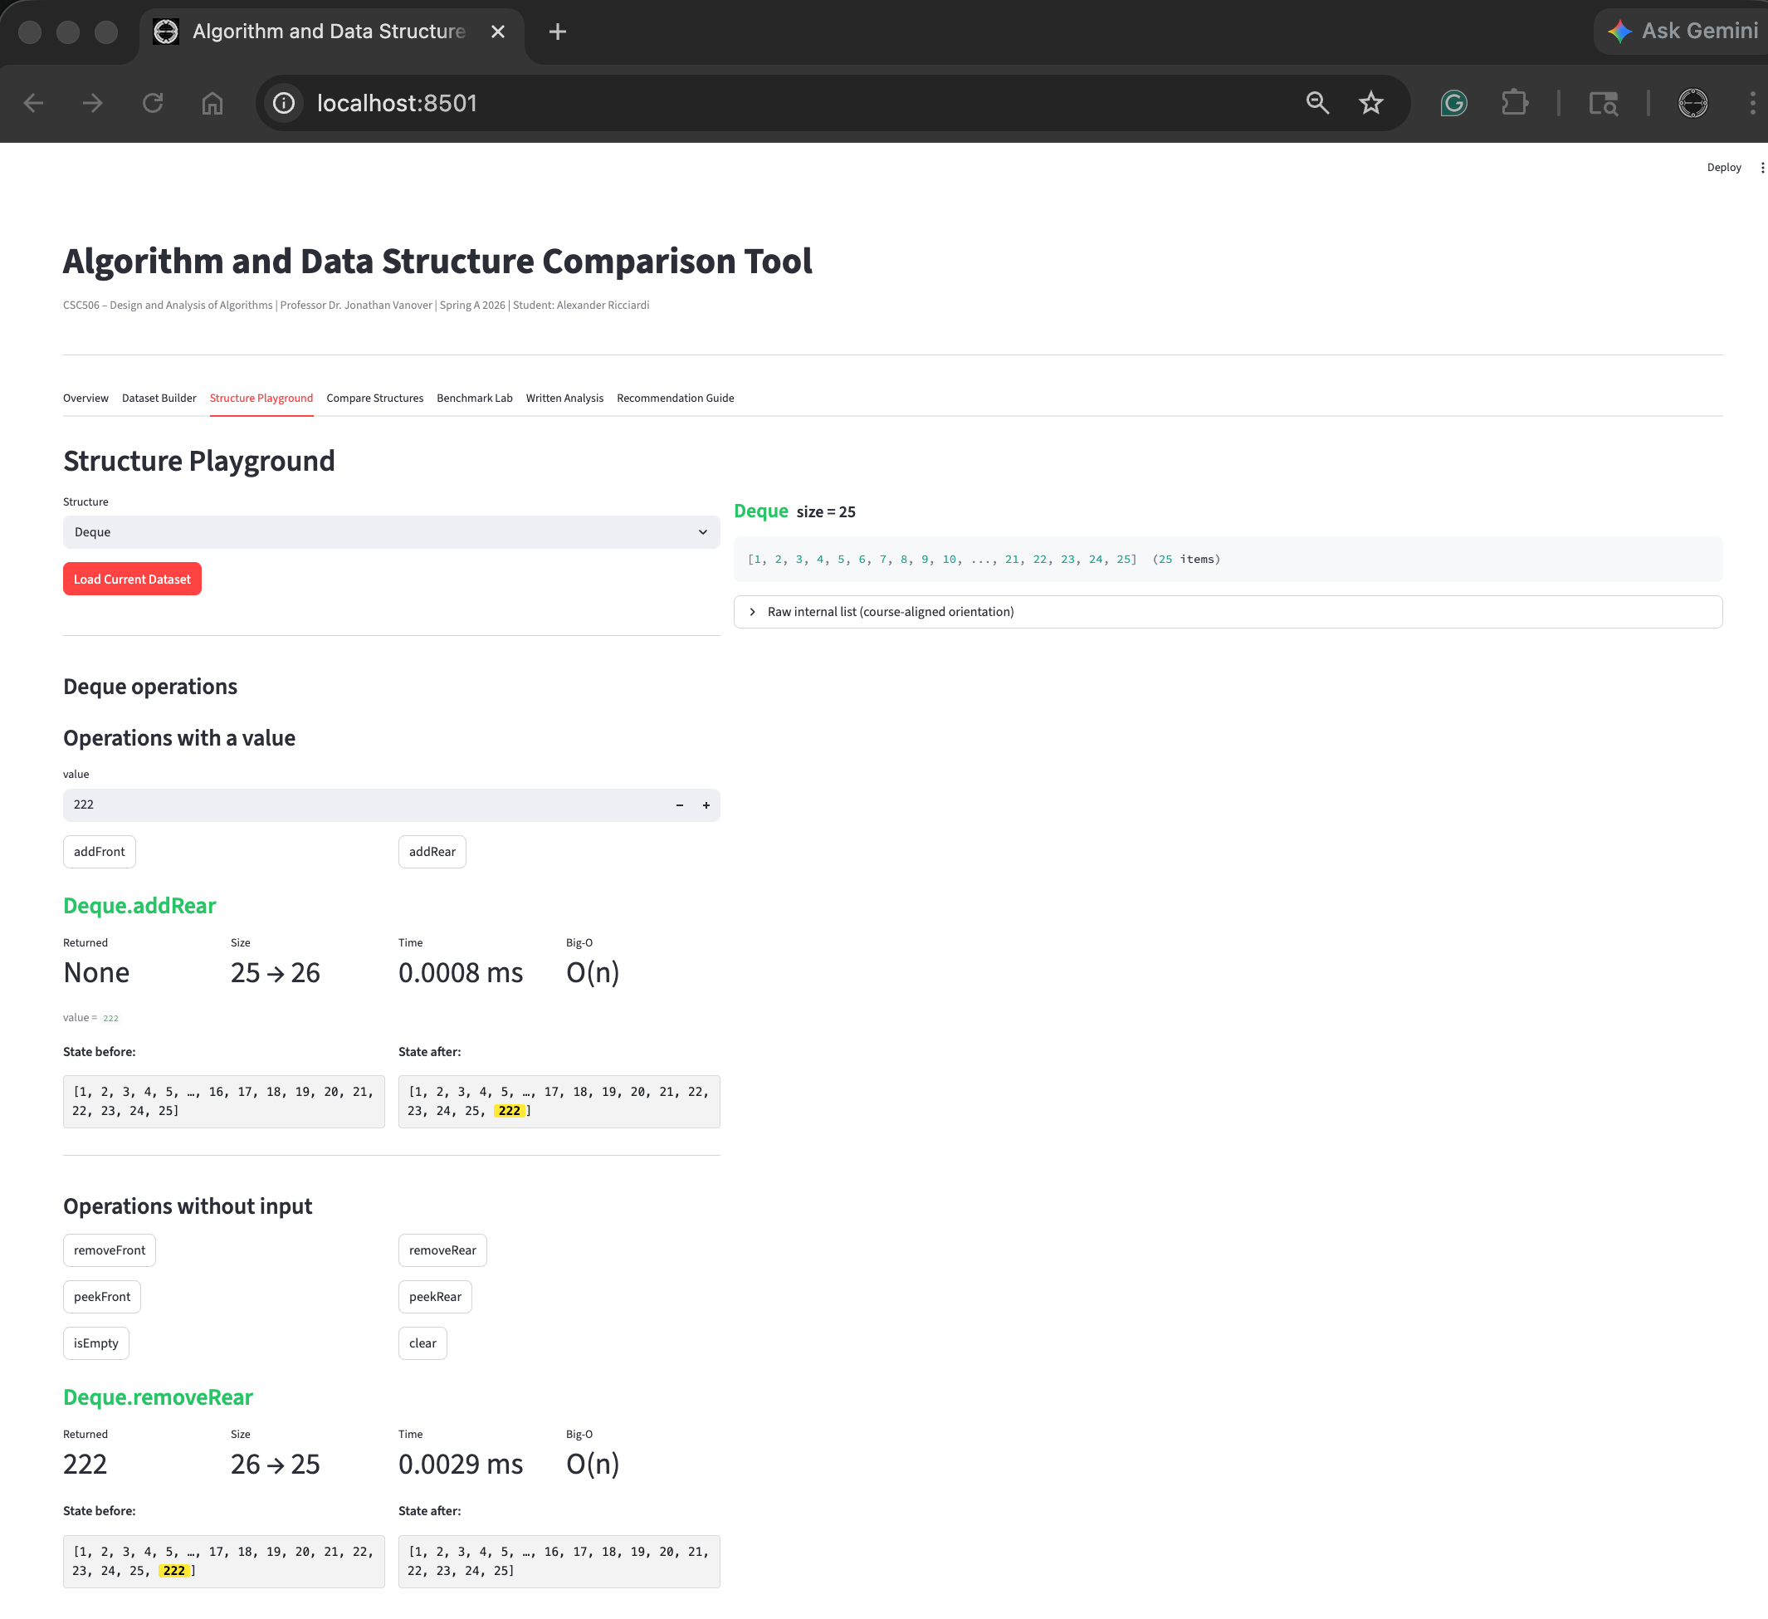

Structure Playground Feature – Dequeue PeekFront and PeekRear
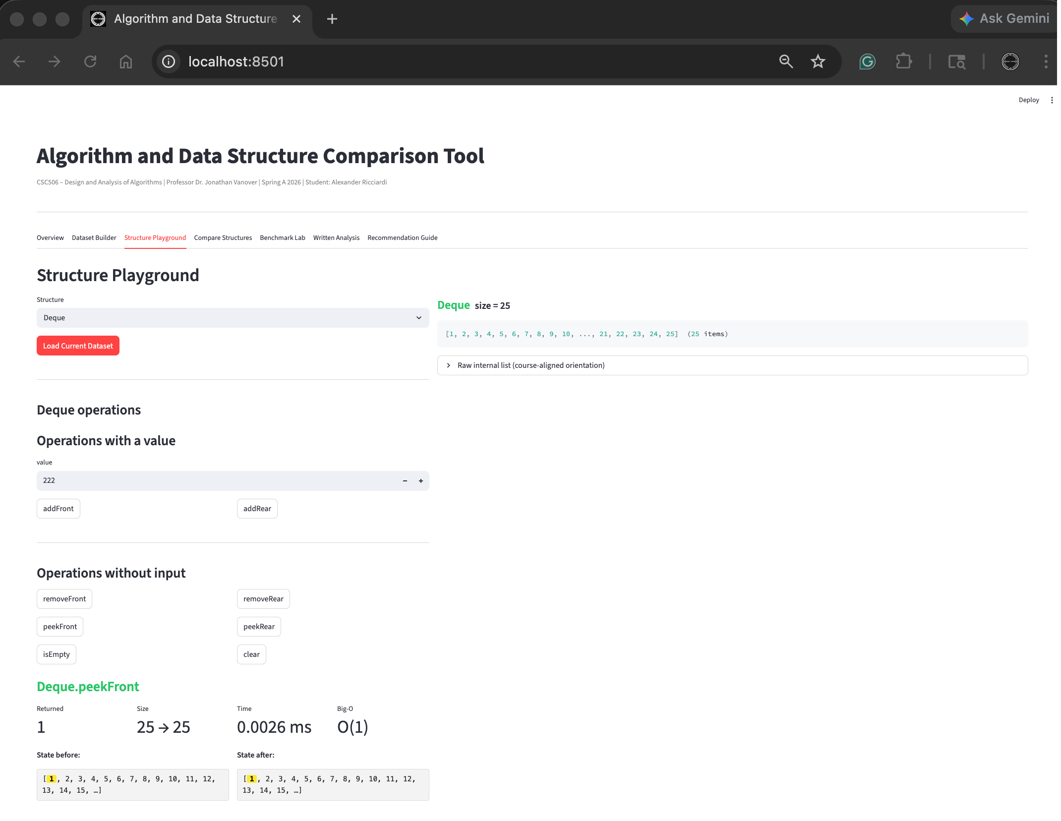
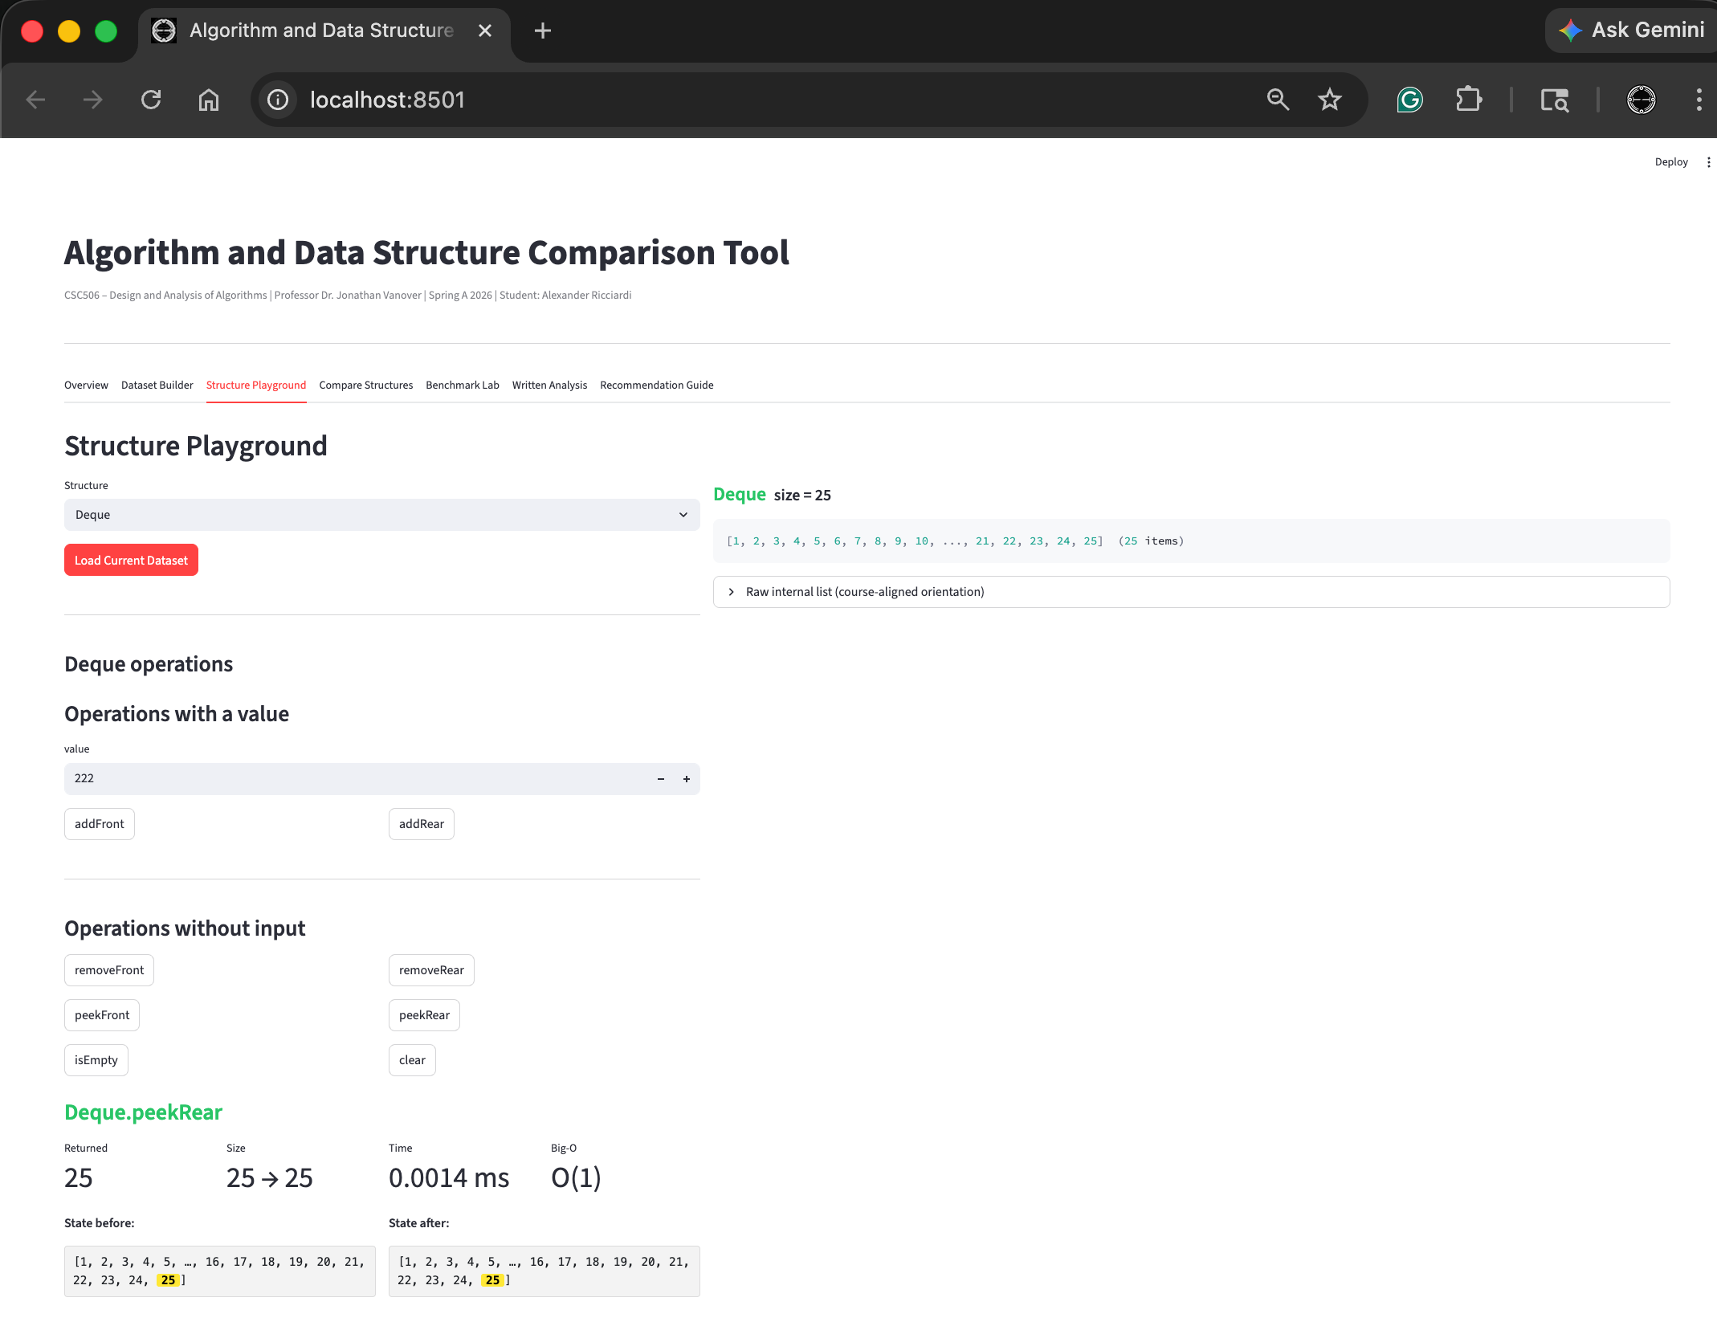
Structure Playground Feature – Dequeue IsEmpty and Clear
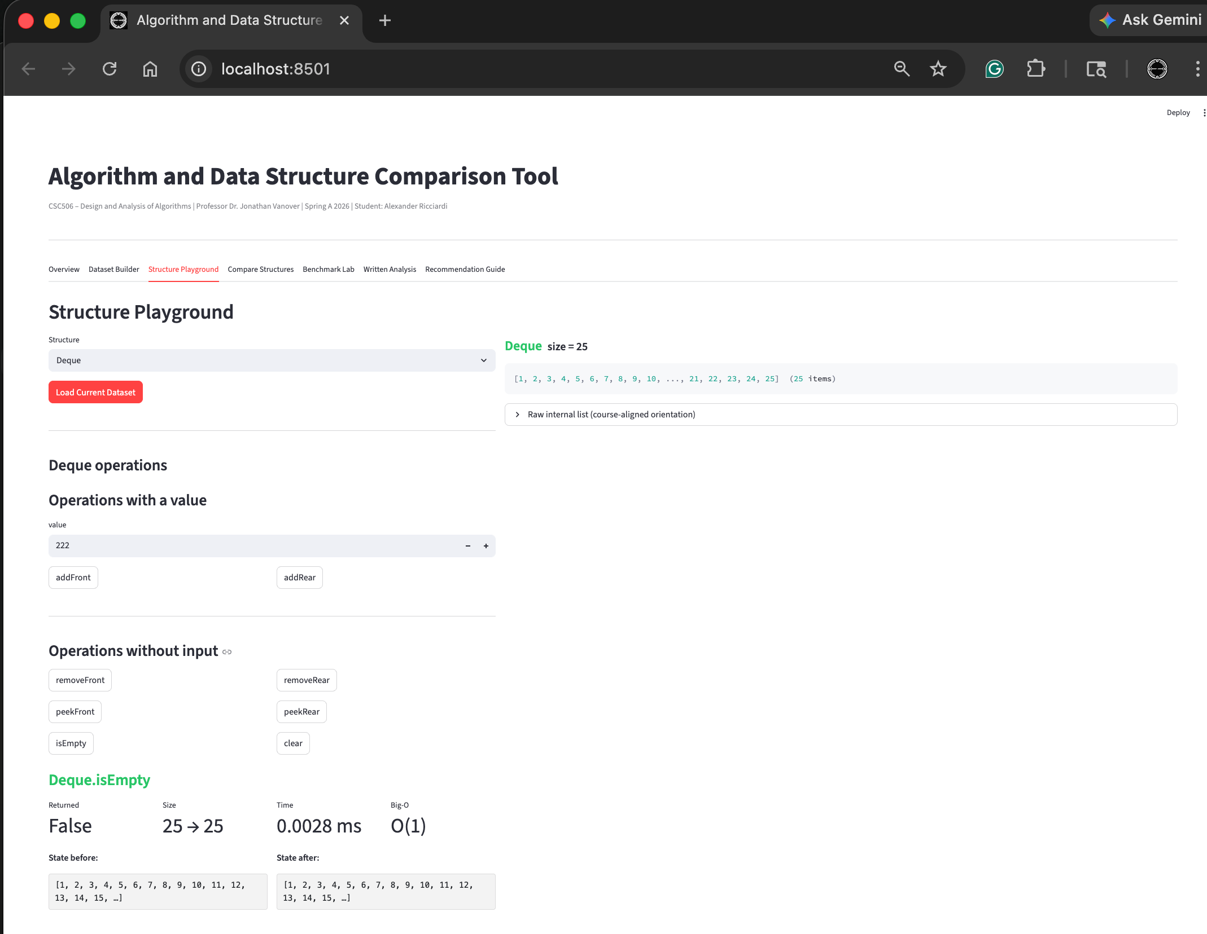
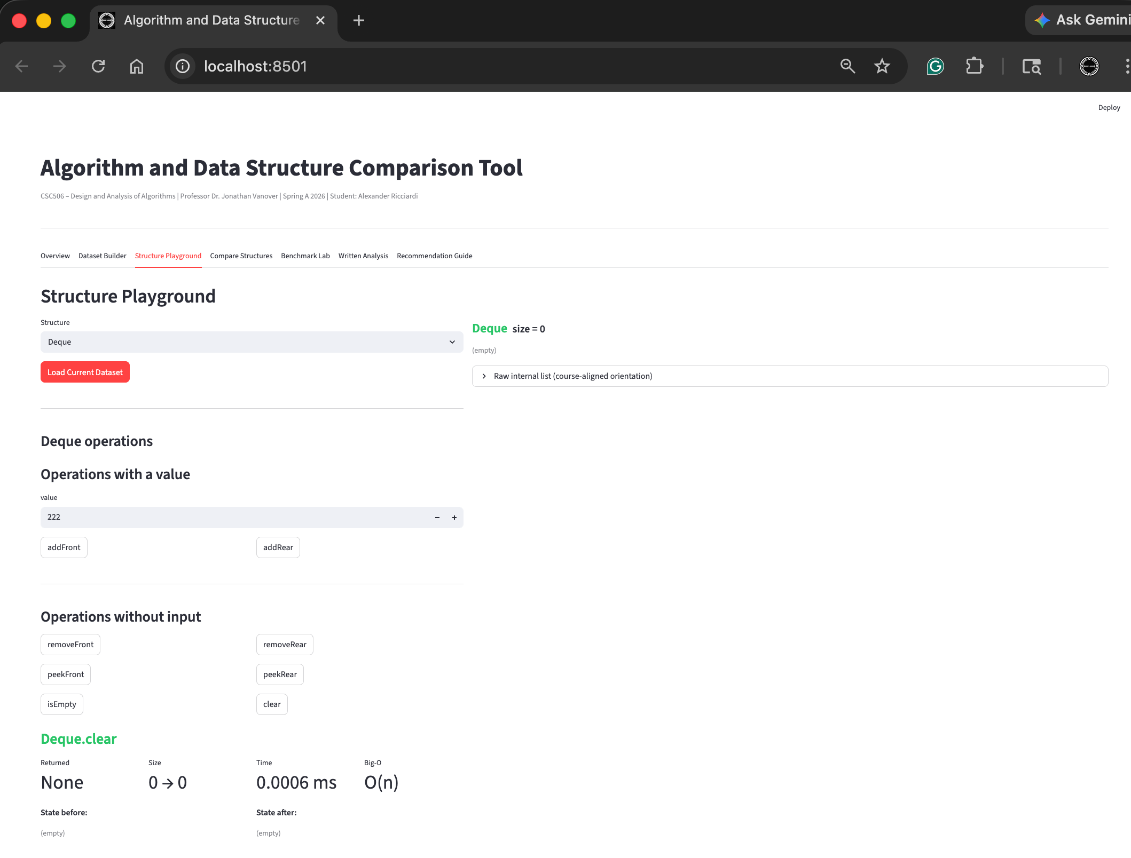
Structure Playground Feature – LinkedList Insert Front and Delete Front
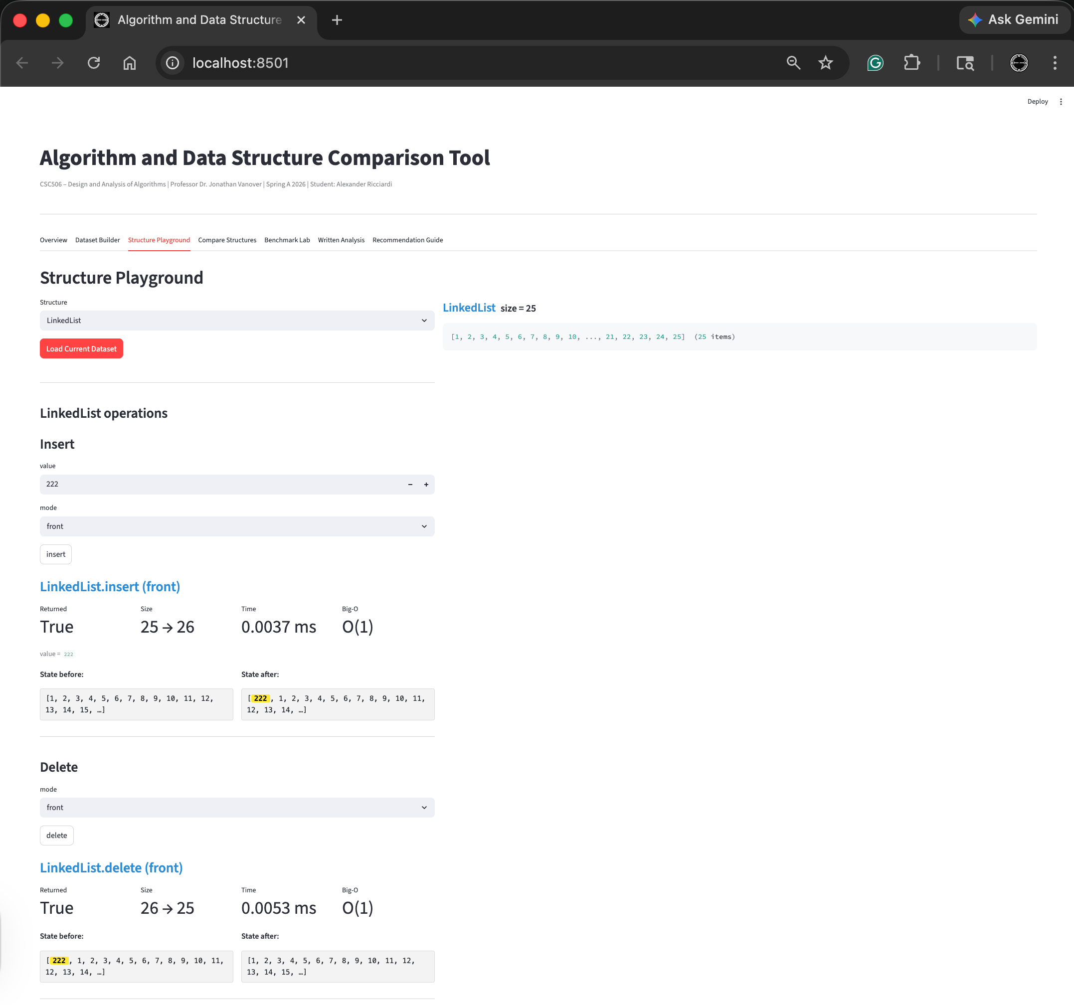

Structure Playground Feature – LinkedList Insert Rear and Delete Rear
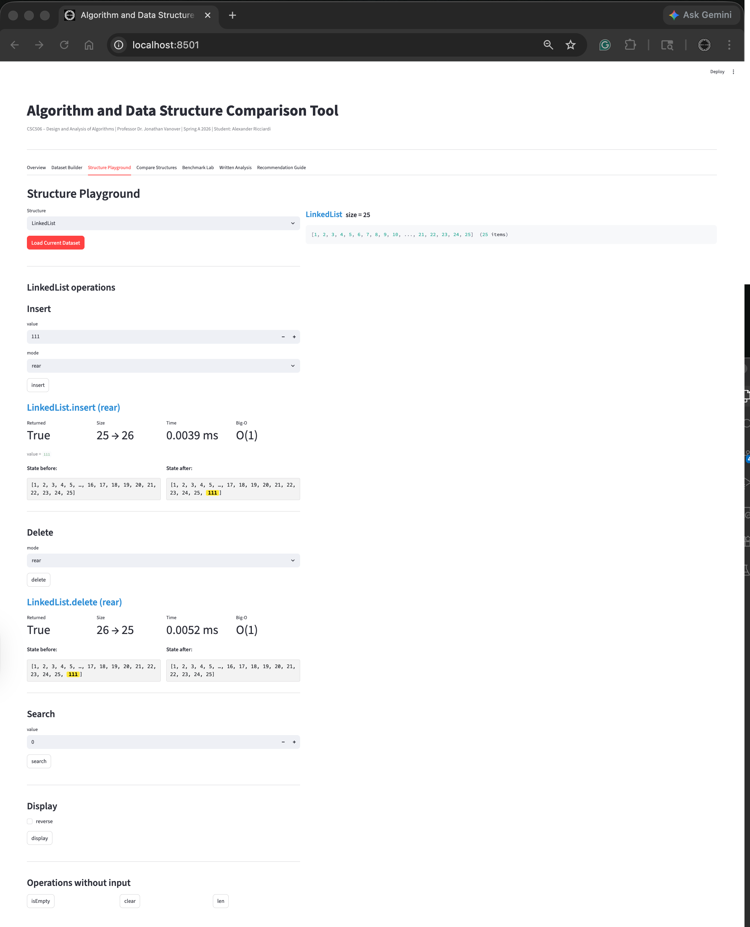
Structure Playground Feature – LinkedList Insert Before 12 Delete Before 12
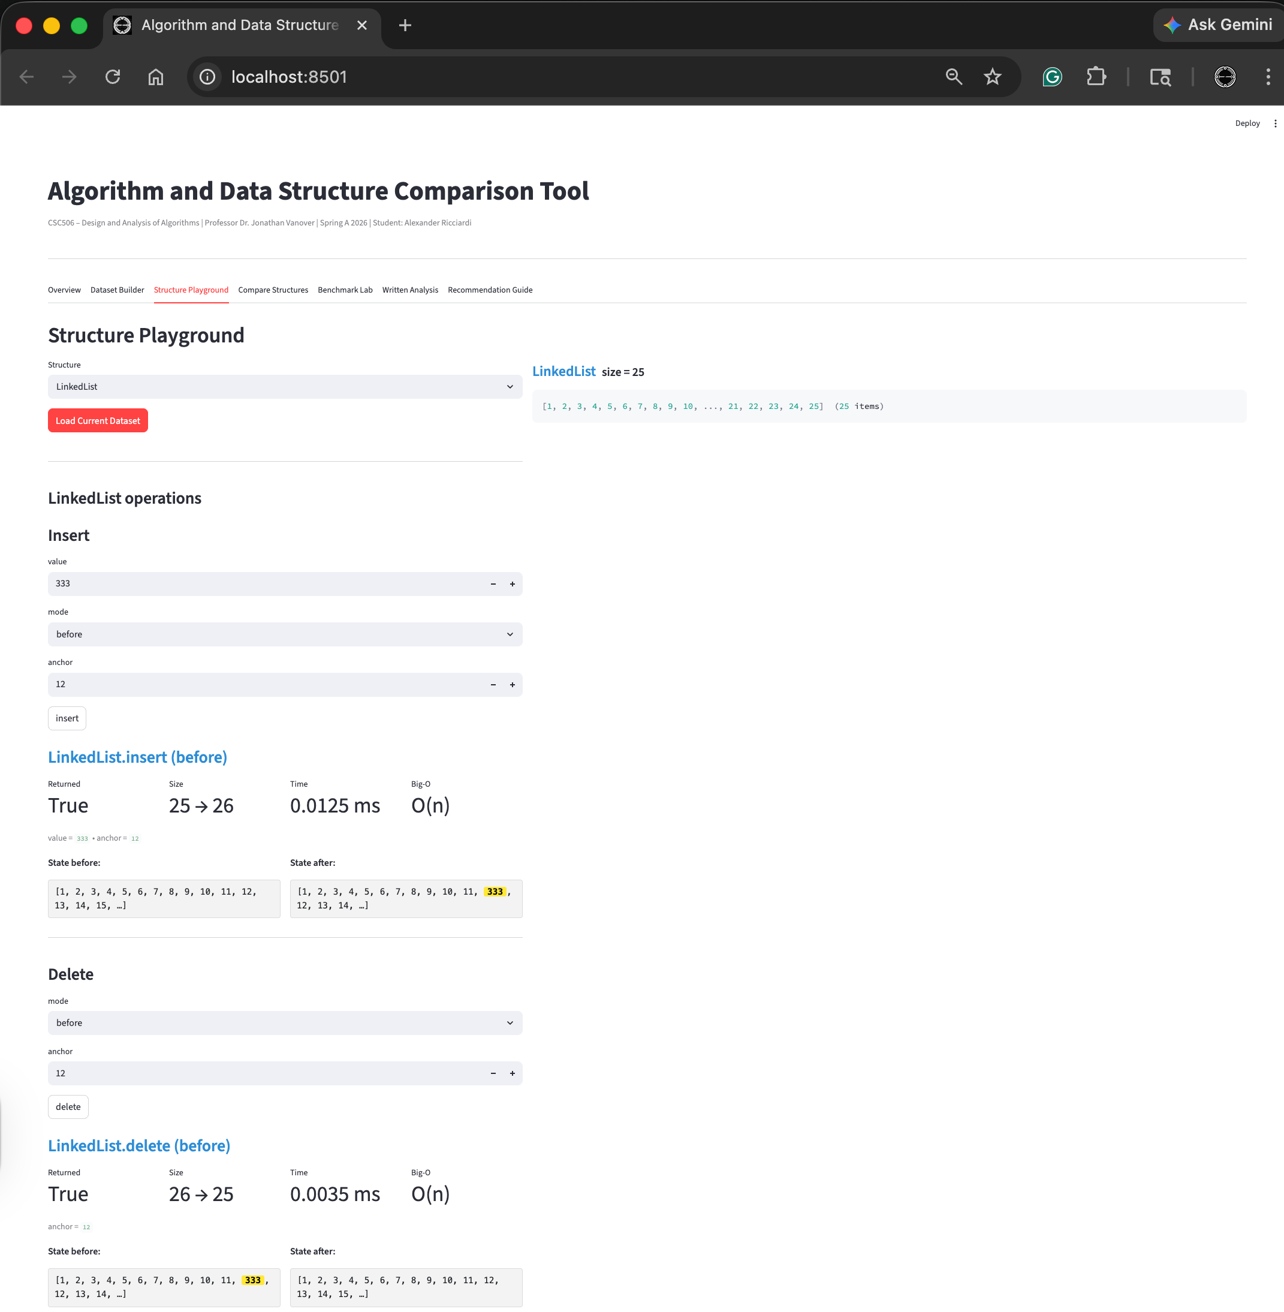
Structure Playground Feature – LinkedList Insert After 12 Delete After 12
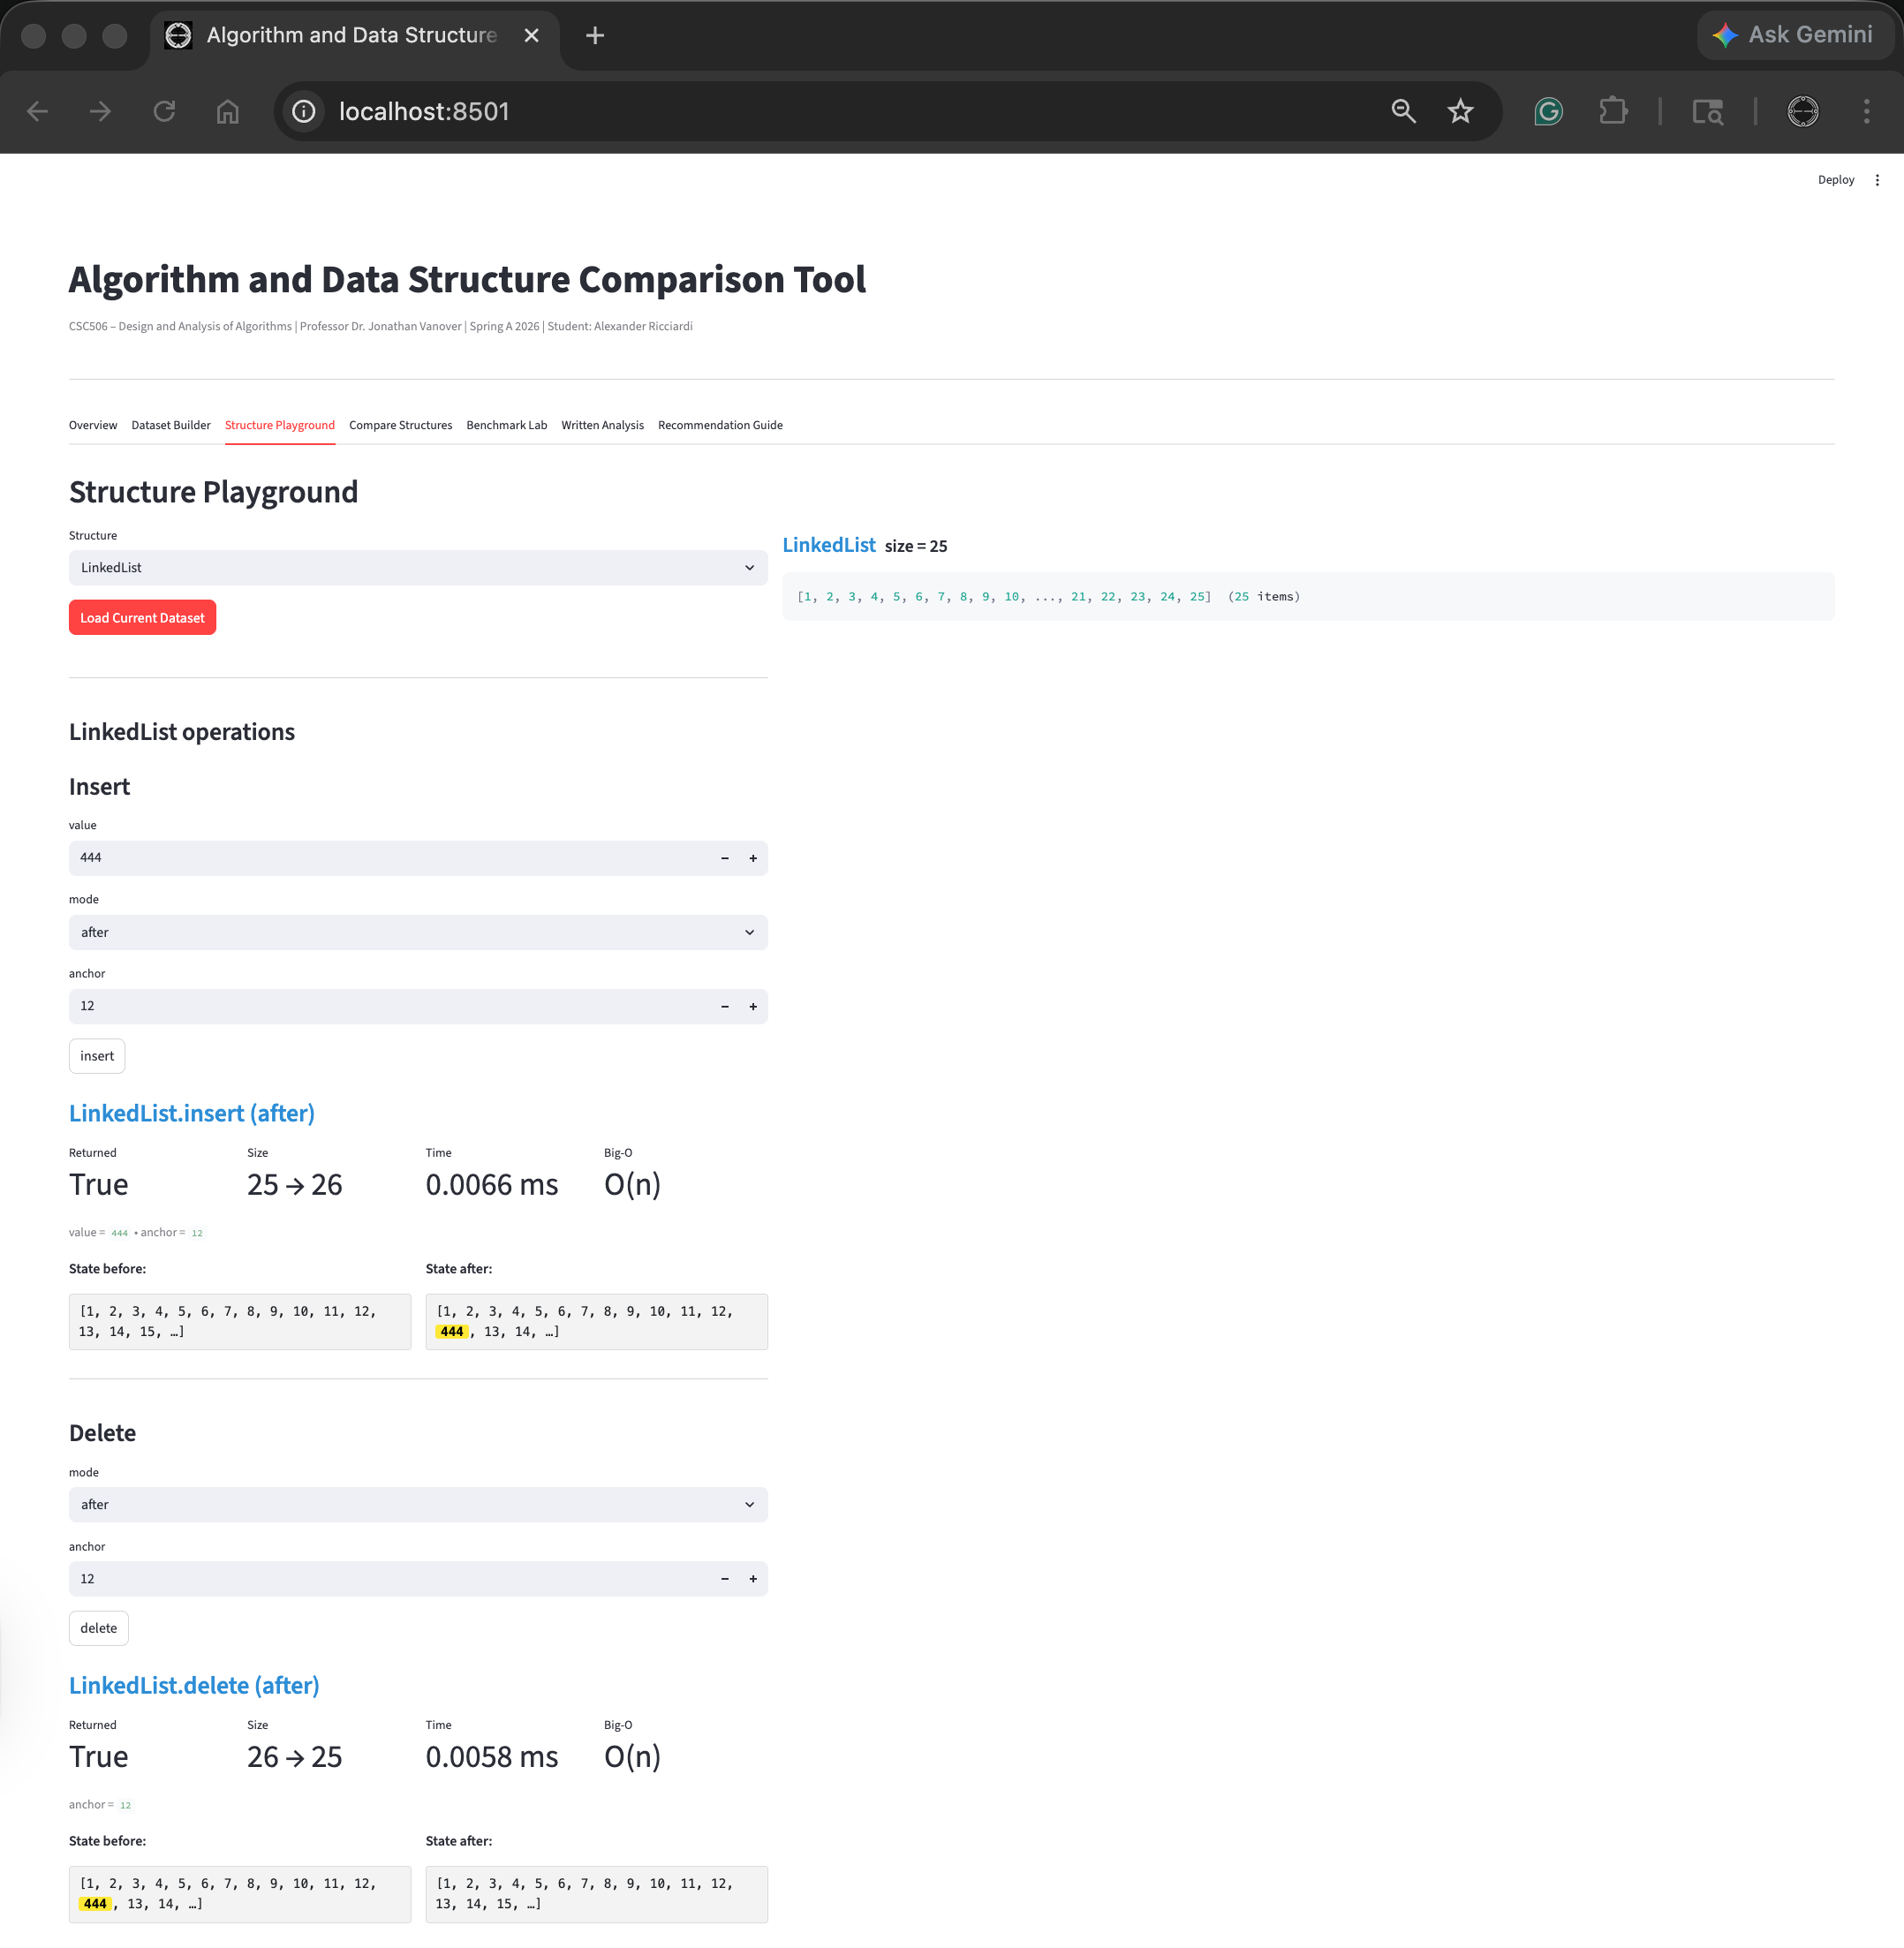

Structure Playground Feature – LinkedList Delete Value 12 and then Search Value 12
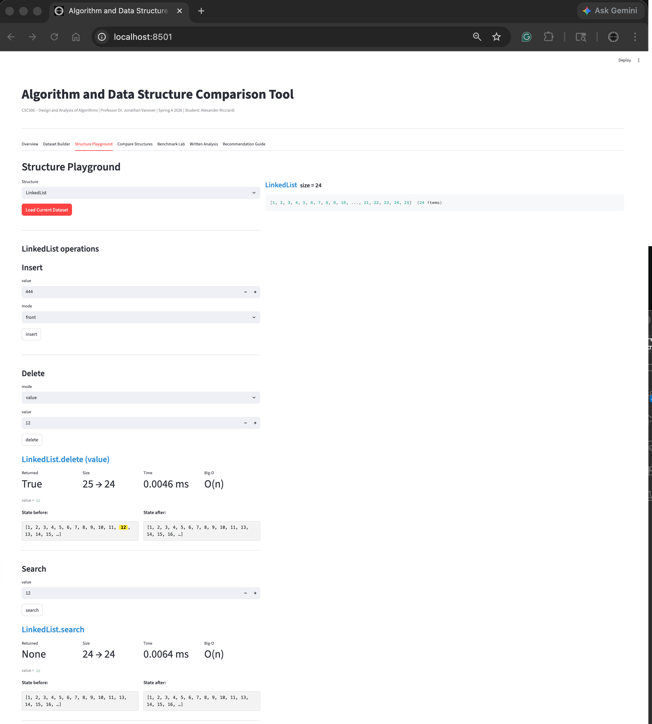

Structure Playground Feature – LinkedList Search Value 15
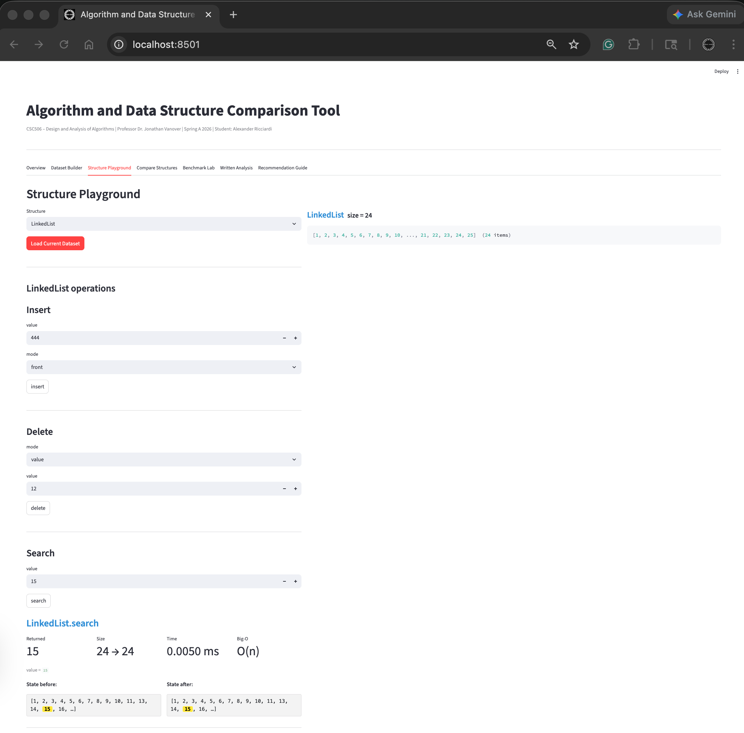

Structure Playground Feature – LinkedList Reverse Display
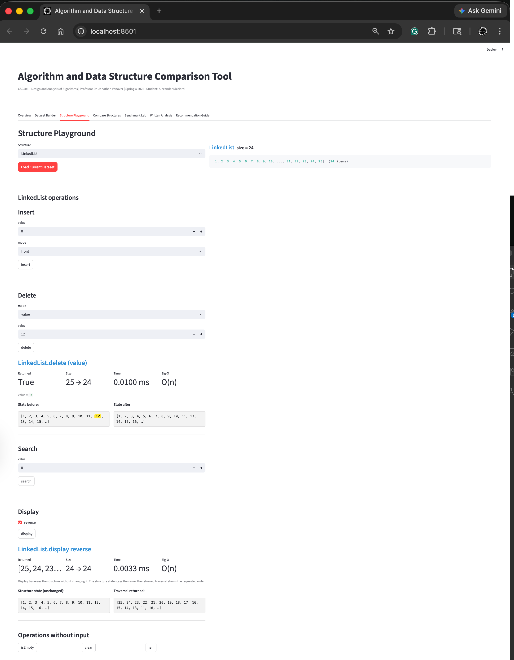
Structure Playground Feature – LinkedList Length
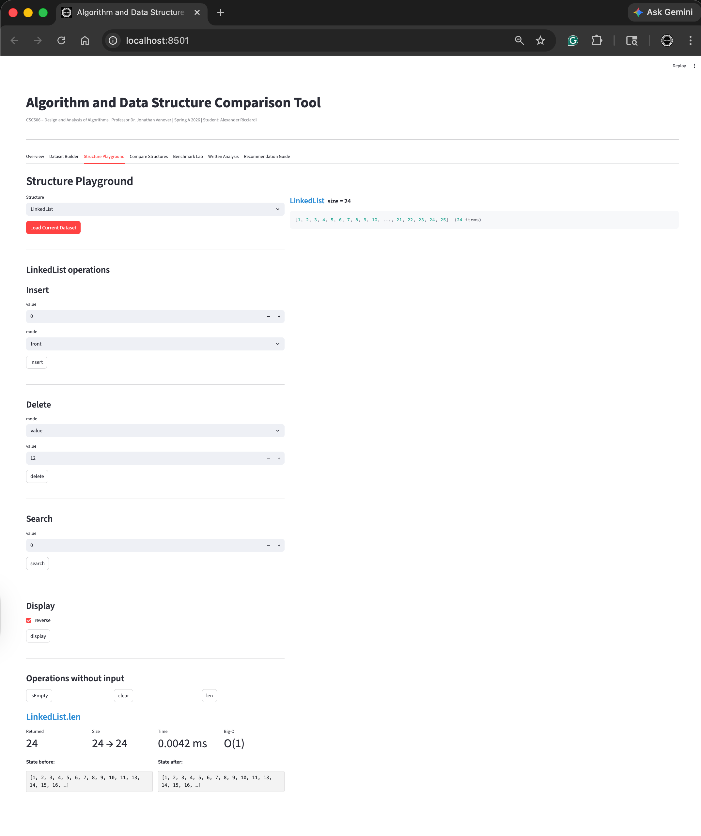

Structure Playground Feature – LinkedList Length
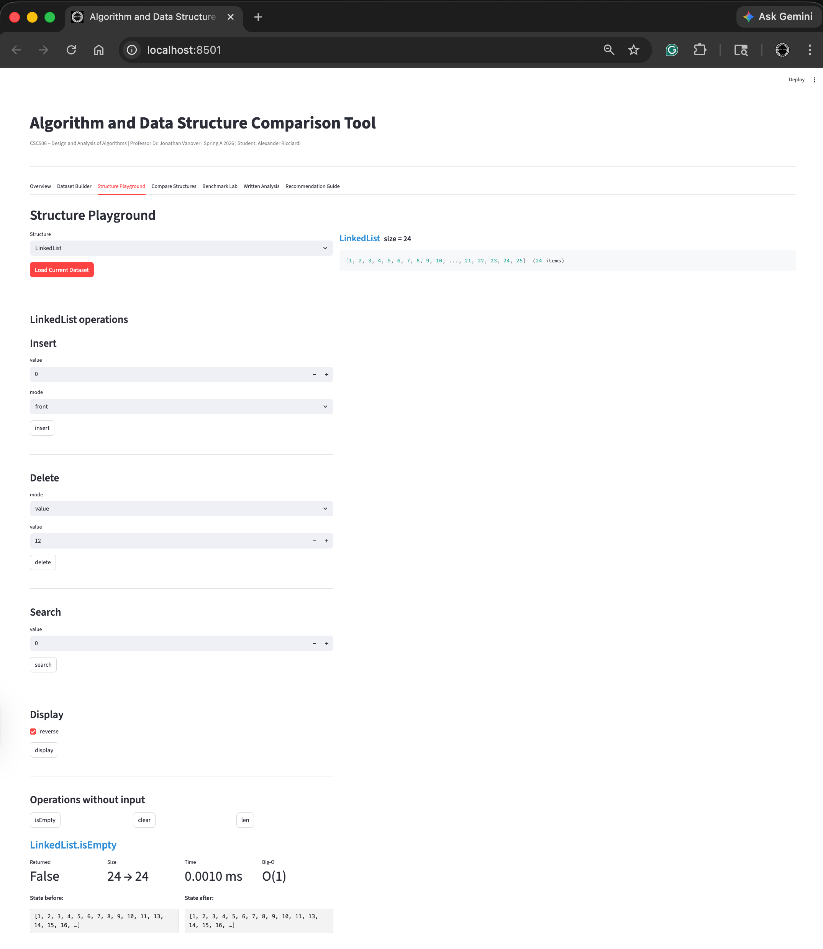

Structure Playground Feature – LinkedList Clear
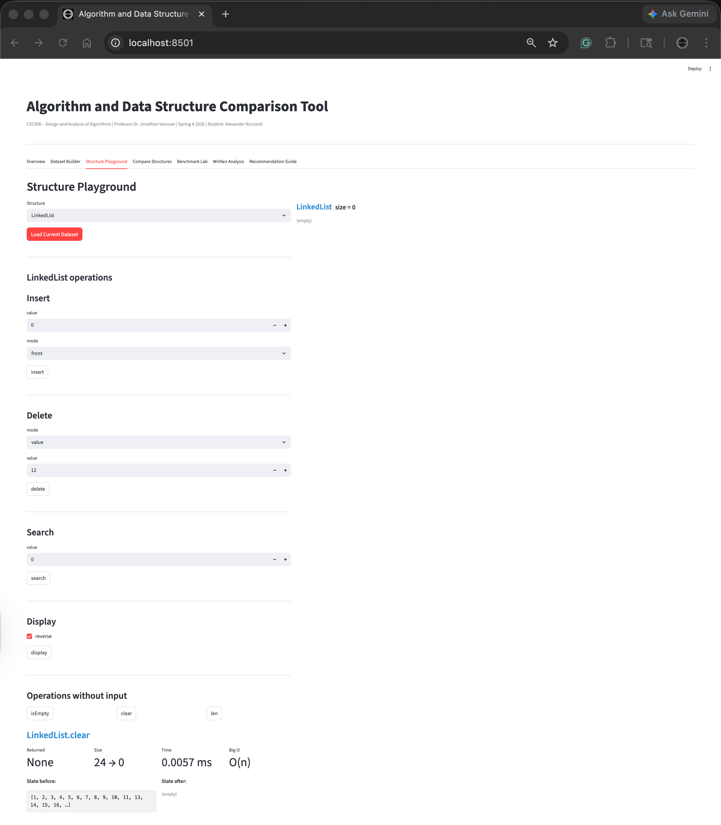

Compare Structures Feature (Comparison Table for full Comparison see Recommendation Guide)


Compare Structures Feature
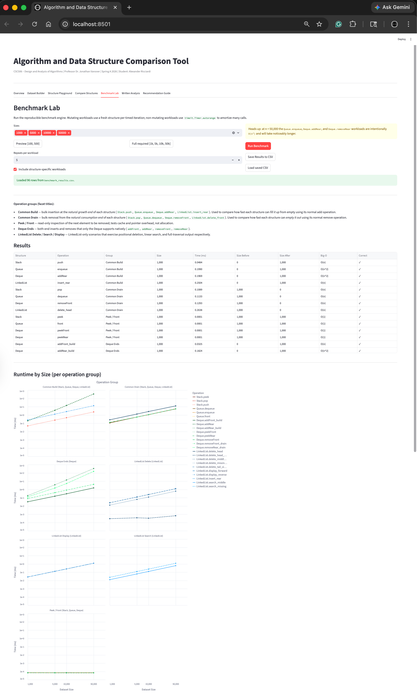
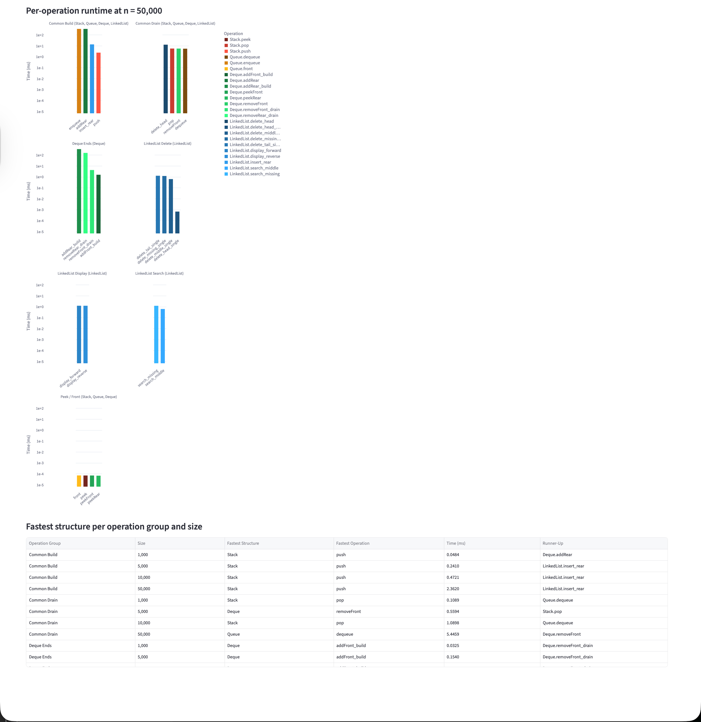

Written Analysis (see the provided Word Doc for the full text)
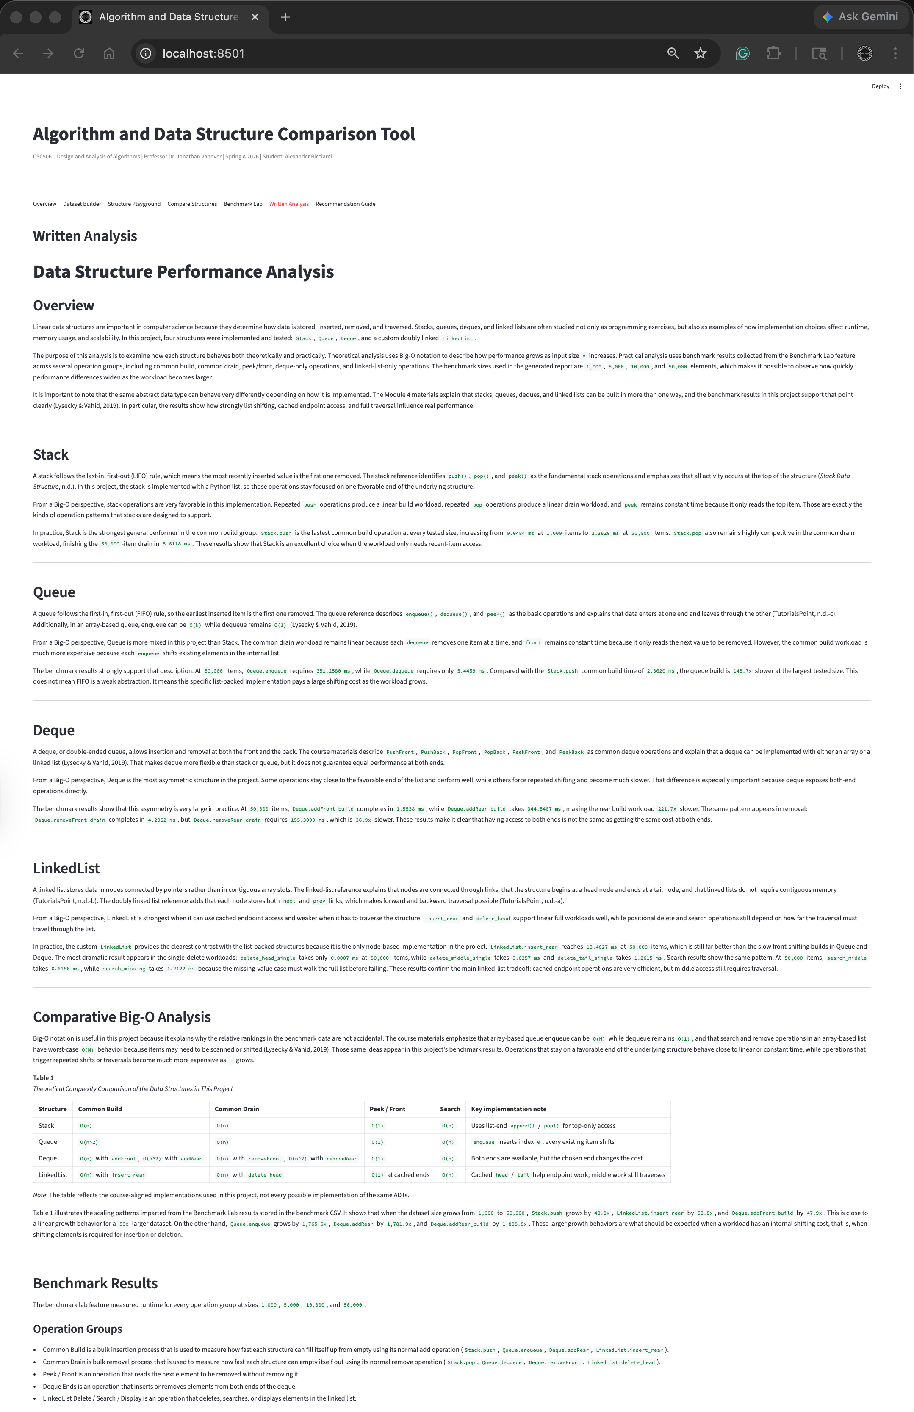
Recommendation Guide (see the provided Word Doc for the full text)
